

Design and Development of Fall Analyzer

A Thesis Proposal

Presented to the Faculty of the

Department of Electronics and Communications Engineering

Gokongwei College of Engineering

De La Salle University

In Partial Fulfillment

Of the Requirements

for the Degree of

Bachelor of Science in Electronics and

Communications Engineering

*Bachelor of Science in Computer Engineering

by

AMBION, Paulo Miguel M.

*CUNANAN, Aenon Mari Viel T.

HARRIS, Edward Brian L.

April 2018

ORAL DEFENSE RECOMMENDATION SHEET

This thesis, entitled Design and Development of Fall Analyzer, prepared and submitted by the thesis group, composed of:

AMBION, Paulo Miguel M.

*CUNANAN, Aenon Mari Viel T.

HARRIS, Edward Brian L.

in partial fulfillment of the requirements for the degree of **Bachelor of Science** **in Electronics and Communications Engineering (BS-ECE) and *Bachelor of Science in Computer Engineering (BS-CpE)** has been examined and is recommended for acceptance and approval for **ORAL DEFENSE.**

|  |  |  |
| --- | --- | --- |
|  |  |  |
| Engr. Alexander CO Abad | |
| *Thesis Adviser* | |
|  | |
|  | |

April 2018

THESIS PROPOSAL APPROVAL SHEET

This thesis proposal entitled Design **and Development of Fall Analyzer**, prepared and submitted by:

AMBION, Paulo Miguel M.

*CUNANAN, Aenon Mari Viel T.

HARRIS, Edward Brian L.

With group number ESG-S03 in partial fulfillment of the requrements for the degree of **Bachelor of Science** **in Electronics and Communications Engineering (BS-ECE) and *Bachelor of Science in Computer Engineering (BS-CpE)** has been examined and is recommended for acceptance and approval.

**PANEL OF EXAMINERS**

|  |  |  |  |  |  |  |
| --- | --- | --- | --- | --- | --- | --- |
|  |  | **Dr. Roy Francis Navea, Ph.D.** | | |  |  |
|  |  | *Chair* | | |  |  |
|  |  |  | | |  |  |
|  |  |  | | |  |  |
|  | | |  |  | | |
|  | | |  |  | | |
| **Engr. Noriel C. Mallari** | | |  | **Dr. Melvin K. Cabatuan, Ph.D.** | | |
| *Member* | | |  | *Member* | | |
|  | | |  |  | | |
|  | | |  |  | | |
|  | | |  |  | | |
|  |  | **Engr. Alexander Co Abad** | | |  |  |
|  |  | ***Adviser*** | | |  |  |
|  |  |  | | |  |  |
|  |  |  | | |  |  |
|  |  | Date: April 2018 | | |  |  |

2018

All Rights Reserved. No Part of this publication may be reproduced, stored in an information retrieval system, or transmitted, in any form or by any means, electronic, mechanical, by photocopying, scanning, recording, or otherwise, except under the terms of aplicable law.

TABLE OF CONTENTS

**ORAL DEFENSE RECOMMENDATION SHEET 2**

**THESIS PROPOSAL APPROVAL SHEET 3**

**TABLE OF CONTENTS 5**

**LIST OF FIGURES 6**

**LIST OF TABLES 8**

**ABBREVIATIONS 9**

**GLOSSARY 10**

**Chapter 1**

INTRODUCTION 11

1.1. Background of the Study 12

1.2. Prior Studies 14

1.3. Statement of the Problem 16

1.4. Objectives 18

1.4.1. General Objective 18

1.4.2. Specific Objectives 18

1.5. Significance of the Study 19

1.6. Scopes and Delimitations 20

1.6.1. Scopes 20

1.6.2. Delimitations 22

1.7. Description of the Project 23

1.8. Estimated Work, Schedule and Budget 33

1.9. Overview 39

**Chapter 2**

LITERATURE REVIEW 40

2.1. Existing Work 41

2.2. Lacking in the Approaches 45

**CHAPTER 3**

THOERETICAL CONSIDERATIONS 49

3.1 Summary 50

3.2 Fall Detection 50

3.2.1 Motion Detection and Direction of Fall 50

3.2.2 Location of the User 51

3.2.3 Alert System 51

3.2.4 Graphical User Interface (GUI) 51

3.2.5 Sections of the Body 52

3.2.6 Trip, Stumble and Fall 52

3.2.7 Vector Analysis of Fall 53

3.3 Pre, During and Post Detection of Fall 54

3.3.1 Pre-fall Detection 54

3.3.2 During the fall Detection 54

3.3.3 Post Fall Detection 55

**CHAPTER 4**

DESIGN CONSIDERATION 56

4.1 Summary 57

4.2 Development of Fall Detector 58

4.2.1 Fall Analyzer and Motion Detection Using Accelerometers 61

4.3 Languages Used 65

**CHAPTER 5**

METHODOLOGY 66

5.1 System Process 67

5.1.1 Device Initialization 69

5.1.2 Notification System 71

5.2 Implementation 72

5.2.1 Preparation, Setup and Data Acquisition 73

5.3 Evaluation 77

**CHAPTER 6**

RESULTS AND DISCUSSION 78

6.1 Direction of Fall Output 79

6.2 Motion Detection Data 81

6.3 Confusion Matrix 82

6.4 Notification System 83

**CHAPTER 7**

CONCLUSIONS, RECOMMENDATIONS, AND FUTURE DIRECTIVES 85

7.1 Concluding Remarks 86

7.2 Contributions 88

7.3 Recommendations 89

7.4 Future Prospects 90

**References** 91

LIST OF FIGURES

Figure 1: Location of the device on the user 26

Figure 2: Initial User Setup 27

Figure 3: User Setup, logging in and password setting 27

Figure 4:Profile Setup 28

Figure 5: Responder’s Setting 28

Figure 6: Confirmation of Identification and password 29

Figure 7. Setup success page 29

Figure 8: Storage Selection 31

Figure 9: Profile Tab 32

Figure 10: Responders Tab 32

Figure 11: Activity Log 33

Figure 12: Prompt 33

Figure 13: Device on the user 54

Figure 14: Schematic Diagram of the Device 59

Figure 15: Fall Analyzer Circuit Design 60

Figure 16: External Accelerometer and Arduino 101 61

Figure 17: MicroSD Card Module 61

Figure 18: GPS/GSM Shield 62

Figure 19: Buzzer, LEDs and Override Button 62

Figure 20: Device Proper 63

Figure 21: Input Analyzation flowchart (a) 65

Figure 22: Input Analyzation flowchart (b) 66

Figure 23: Fall Detection Device 67

Figure 24: System Block Diagram 69

Figure 25: User Initialization 71

Figure 26: System Flowchart 73

Figure 27: Waterfall Pattern 74

Figure 28: Block Diagram 75

Figure 29: Flow Chart 76

Figure 30: Activity Log 79

Figure 31: Notification Message 85

Figure 32: Location of Fall from Google Maps 86

LIST OF TABLES

Table 1.1: Prior Studies 14

Table 1.2: Estimated Work and Schedule 33

Table 1.3: Estimated Budget 36

Table 2.1: Lacking in the Approaches 45

Table 6.1: Falling Motions Data 79

Table 6.2: Motion Detection Data 81

Table 6.3: Confusion Matrix 82

ABBREVIATIONS

**ADL** Activities of Daily Living

**CSS** Cascading Style Sheet

**GND** Ground

**GPS** Global Positioning System

**GSM** Global System for Mobile

**GUI** Graphical User Interface

**INT** Interrupt

**LED** Light Emitting Diode

**LFT** Lower Fall Threshold

**LPV** Lower Peak Values

**MEMS** Micro Electro Mechanical System

**MISO** Master In Slave Out

**MOSI** Mater Out Slave In

**RTC** Real Time Clock

**SCK** System Clock

**SCL** Clock Line

**SD Card** Secure Digital Card

**SDA** Data Line

**SMS** Short Message Service

**SS** Chip Select

**SVM** Support Vector Machine

**UFT** Upper Fall Threshold

**UTC** Universal Time Clock

**VCC** Collector Supply Voltage

GLOSSARY

|  |  |  |
| --- | --- | --- |
| Fall |  | * To come and go down suddenly from a standing position * To let yourself come or go down to a lower position * To decend freely by th force of gravity   Synonyms: trip, stumble |
|  |  |  |

Chapter 1

INTRODUCTION

|  |
| --- |
|  |

INTRODUCTION 11

1.1. Background of the Study 12

1.2. Prior Studies 14

1.3. Statement of the Problem 16

1.4. Objectives 18

1.4.1. General Objective 18

1.4.2. Specific Objectives 18

1.5. Significance of the Study 19

1.6. Scopes and Delimitations 20

1.6.1. Scopes 20

1.6.2. Delimitations 22

1.7. Description of the Project 23

1.8. Estimated Work, Schedule and Budget 33

1.9. Overview 39

|  |
| --- |
|  |

1. Background of the Study

Accidents which are external causes of death and injury is the 4th leading cause of death for all ages in the Philippines. Based on the statistics from 1975 to 2002, injury mortality rates have more than doubled from 19.1 in 1975 to 41.9 in 2003 per 100,000 population. One of the top five leading causes of death due to accidents in the Philippines for all ages is accidental falls. From the 4, 947 patients admitted to the Division of Trauma during a study period, 231 (4.7%) deaths were recorded and 205 (88.7%) of these were males. 135 (58.4%) from death were victims of penetrating injuries, and 96 (41.6%) had blunt trauma (vehicular injury in 66, falls in 15, mauling in 5, and other blunt injuries in 10). Intentional causes of injury (stab wound, gunshot wounds, and blunt assault) led to 151 (65%) deaths, while unintentional causes (vehicular crashes and falls) caused 80 (35%) deaths. (Marinas, Maddunba, Consunji, & Dela Paz Jr., 2011)

From worldwide statistics, 138 children, aged 0 to 18 years die daily due to falls. This translates to around 50,000 children dying each year due to accidental falls. It counts as the fifth leading cause of unintentional deaths of children below 14 years old in the Philippines. Falls were also found to be the leading cause of morbidity and lifelong disability among children. (Crisostomo, 2014)

From the Filipino elders in a nursing home facility and at the rehabilitation medicine out-patient department of the Philippine General Hospital (PGH), falls are considered one of the most serious health concerns encountered by the elderly. About 30 to 40% of individuals living in the community aged 65 and above fall each year. These accidents are associated with increased morbidity and mortality, and as much as 20 to 30% of those who fall suffer from serious hip fracture and head trauma. Current data show that falls comprise the single largest cause of death due to injury in the elderly. Recovery from falls is often poor because of restricted mobility and functional decline. Most falls have multiple causes, and are usually due to dynamic interplay of predisposing and precipitating factors. (Guevarra & Evangelista, 2010)

1. Prior Studies

Table 1.1 Prior Studies

|  |  |
| --- | --- |
| **Existing Study** | **Description** |
| Design and Development of Fall Detector Using Fall Acceleration (Sudarshan, Raveendra, Prasanna, & Satyanarayana, 2013) | This study aims to design and develop a prototype of an electronic gadget which is used to detect fall among elderly and the patients who are prone to it. A triaxial accelerometer (adx1335) is used in this study to measure the change of acceleration in three axes which are integrated from the body posture. To study the tilt angle, sensors are placed on the lumbar region of the body. To reduce the false alarms, the acceleration values in each axis are compared twice with threshold and a delay of 20 secs between two comparisons. Values of the threshold voltage are selected by experimental methods. The algorithm is executed by microcontroller (PIC16F877A). A GPS receiver uses the location of fall which is programmed to track the subject continuously.  On detection of fall, the device sends a text message through GSM modem, and communicates it to a computer through ZigBee transceivers. The device can also be switched to alarm only if a text message is not required. The prototype developed is tested on many subjects and on volunteers who simulated fall. Out of 50 trials, 96% of accuracy is achieved with zero false alarms for daily activities like jogging, skipping, walking on stairs, and picking up objects. |

*Continued on next page*

*Continued from previous page*

|  |  |
| --- | --- |
| **Existing Study** | **Description** |
| Accurate, Fast Fall Detection Using Gyroscopes and Accelerometer-Derived Posture Information (Li, Stankovic, Hanson, Barth, & Lach, 2009) | As prevalent methods only use accelerometers to isolate falls from activities of daily living (ADL), certain fall-like activities such as sitting down quickly and jumping result in many false positives which make it difficult to distinguish real falls. In some other non-horizontal ending position like falls on the stairs, the use of body orientation is not very useful to detect falls.  This study has created a novel fall detection system using both accelerometers and gyroscopes. Human activities are divided into two categories: static postures and dynamic transitions. By using two tri-axial accelerometers at separate body locations, our system can recognize four kinds of static postures: standing, bending, sitting, and lying. Motions between these static postures are considered as dynamic transitions. Linear acceleration and angular velocity are measured to determine whether motion transitions are intentional. If the transition before a lying posture  is not intentional, a fall event is detected. The algorithm, coupled with accelerometers, reduces both false positives and false negatives, while improving fall detection accuracy. In addition, the solution features low computational cost and real-time response. |

1. Statement of the Problem

Many simple fall related accidents that lead to death or irreversible damage due to slow dissemination or lack of knowledge of responders (e.g. family members, friends or rescuers), can be prevented if information regarding the incident can be sent immediately to a responder.

Fall incidents are enumerated into different circumstances that defines itself as accident. Fall in this study is defined as an act of falling or collapsing or sudden uncontrollable descent or to suddenly go down onto the ground or towards the ground without intending to or by accident (Cambridge University Press, 2017). It can also be defined as a sudden unintentional and uncontrollable descent which can also be classified as to stumble or to trip.

This study would like to give a solution to accidents which can be prevented if knowledge or information regarding the fall incident can be identified and sent quickly. It also aims to give aid to the innovation of the past technologies that has been done in relation to these problems.

Many different studies and technologies are made from the past to detect fall, but these studies differ in accordance on how fall is being focused. The observation of Raul Igual et. al in their fall detection analysis trends states that, in the study of Li, the use of gyroscope and accelerometer in analyzation of fall types such as falling forward, backward and sideways is a success. Compared to the other technologies used to detect fall like image processing, the use of accelerometer is similar to this study. The advantage of this study over Li’s is that in her study, she located the sensors on the waist and chest, whereas this study will locate the sensors on the waist and on the hip as based from the past studies these are better locations to achieve a higher success rate. (Igual, Medrano, & Plaza, 2013)

1. Objectives
   1. General Objective

To design a device that can detect user’s motion and can send a notification to responder/s via Global System for Mobile (GSM) when fall is detected.

* 1. **Specific** Objectives

1. To develop a system that can analyze the duration and direction of the fall whether the user has been fallen backward, forward, or sideward with 80% of accuracy upon detection.
2. To create an algorithm that will store data collected from the user to a secure digital card (SD-card) that has user-friendly functions.
3. To collect data that will be stored in the database from the user such as location and certain motions using Global Positioning System (GPS) and accelerometer respectively.
4. To develop a system that will allow the device to send information to the responder/s.
5. To develop an algorithm that can detect specific motions of the user such as standing, walking and lying.
6. Significance of the Study

Imagine the advantages of having a device that can detect and acknowledge a person’s motion specifically when they unintentionally fell or tripped. As fall is one of the leading causes of death, it is an advantage to know how and when to help the victims after the incident.

This project aims to create a device that will innovate the detection of such incident. It also aims to notify certain responders when the said incident happened. By using this device, the goal to respond to fall related accidents will be achieved. It will be a solution to the fast-growing statistics of deaths, and other injuries that fall related accidents give.

Also, as the device is done, it can be used for further development of fall analyzer with the use of accelerometer. It can also be used in the medical field and through innovation, the detection and notification of a fallen patient can be recognized easily which may eventually lead to the prevention of fall related accidents.

1. Scopes and Delimitations
   1. Scopes

* The device can only detect limited fall directions such as forward, backward and sideward.
* The device will gather the data for the motion and GPS coordinates in real time.
* This project will only require 30 people with an age range of 8 to 24 years old as test subjects. These subjects will perform activities for raw data gathering and would be translated into digital information eventually.
* A text-based database will be created to store the given data into the SD card. It could only store a limited amount of data so an “Automatic delete and save algorithm” will be implemented to save important data. The device will make a beeping sound to notify the user if it reached 90% of its memory storage. It will automatically clear the data that has been saved and the unnecessary data will be deleted to allocate memory storage.
* The graphical user interface (GUI) must initialize important information of the user such as name, age, address, gender, personal contact, and contact numbers of the responder with their name.
* After the device has detected that the user needs an assistance, the set responder/s will be notified through short message service (SMS). A false alarm button is included in the device so that user has an option to stop the assistance.
* Fall detection is the focus of this project. The waist and side of the hip will have an individual accelerometer to determine basic body orientations such as sitting, standing, walking and lying.
  1. Delimitations
* The communication ability of the device will only be limited to the Philippines.
* SMS are system-generated. The user cannot modify nor manually send SMS however the user can interrupt SMS that will be sent.
* The current location of the user will be retrieved as GPS coordinates and not as the exact address of the user.
* Two accelerometers will be used for the project, one for the upper body and one for the lower body. Two accelerometers are being used in accordance to the effectivity of the same number of sensors from the past related studies. By these, limited motions and body orientation of the user will be detected.

1. Description of the Project

This project is a device that can detect if a user had a sudden fall and the direction on how the user had fallen. It can detect fall directions like forward, backward and sideward. Other motions such as sitting, standing, walking and lying can also be detected as a sub-feature of the device. It is user-friendly because the device can be set by accessing the Graphical User Interface (GUI). This device is designed to detect pre-fall, during the fall and post-fall motions. It can detect pre-fall motions which the user is possibly doing before the fall like sitting, standing or walking. It can also recognize whether the user had fallen and post-fall detection can also be acknowledged in which after the fall GPS coordinates.

When the device detects the said fall related incidents, it will also send a notification through Global System for Mobile (GSM) communication to responders like family members, friends, and other people that the user nominates. The notification also includes the Global Positioning System (GPS) coordinates of the user, with the help of GPS module.

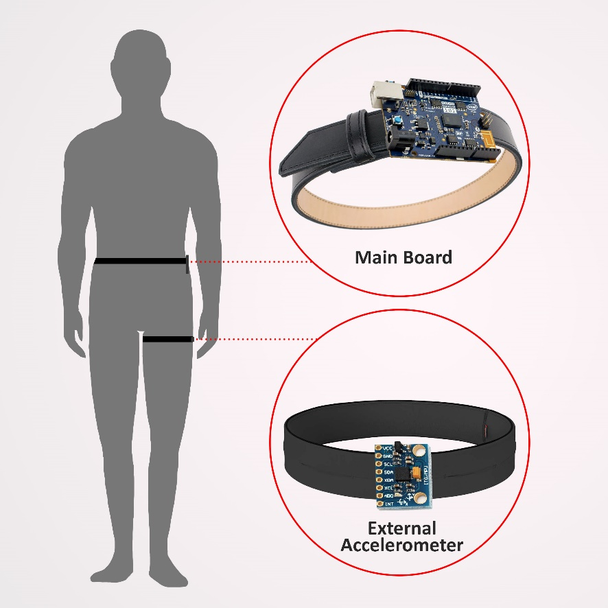

Figure 1: Location of the device on the user

Shown in Figure 1 is the way the device will be worn by the user. The Main Board will be located at the hip of the user and can be attached on its belt. The Main Board is composed of built-in accelerometer and gyroscope. GSM Module and SD Card Module will also be attached on the Main Board. The External Accelerometer will be placed on the thigh of the user which can be attached on a belt or a garter.



Figure 2: Initial User Setup

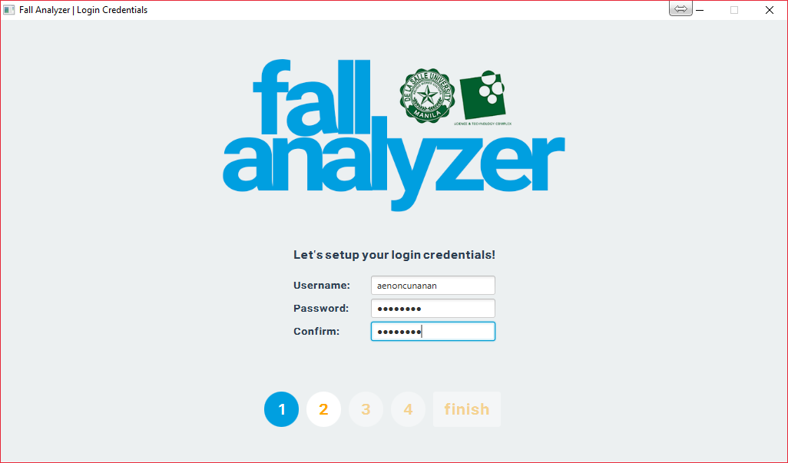

Figure 3: User Setup, logging in and password setting



Figure 4:Profile Setup

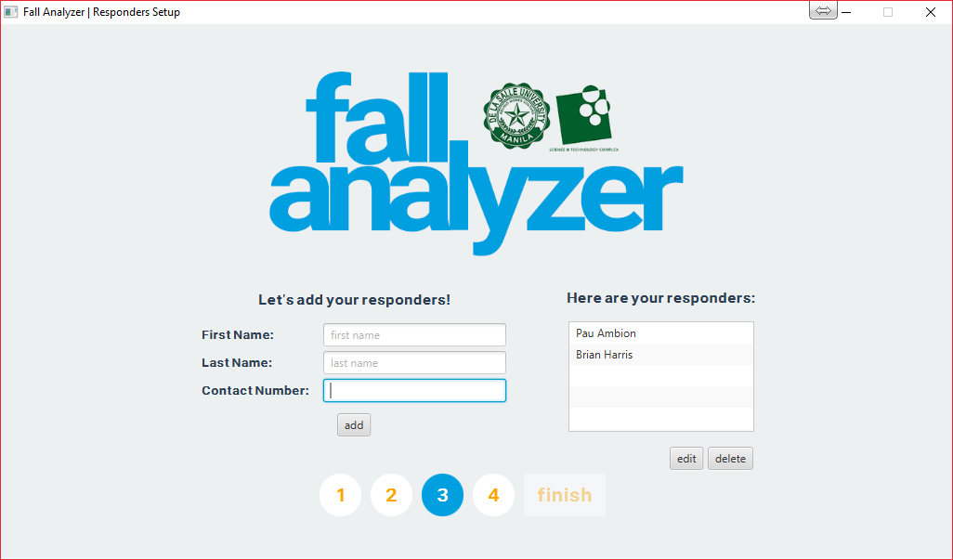

Figure 5: Responder’s Setting



Figure 6: Confirmation of Identification and password



Figure 7. Setup success page

Figure 2 to Figure 7 shows the GUI interface of the device set-up. Through these windows, the user’s information will be recorded wherein the said data may only be edited or changed by the user. Through this setup, responder/s can only view the data recordings. As shown in Figure 2, the simplicity of the interface can be seen as the device is being initialized, which makes the GUI user-friendly. In Figure 3, the device is being setup by asking for a username and a password. Profile setup on Figure 4 initializes the user’s details. In this tab, the complete name, address, contact number and gender is being registered. In Figure 5, the profile of the responder/s is being setup which includes the name and immediate contact (mobile) number. Confirmation of username and password can be seen in Figure 6. Lastly, the success page in Figure 7 is shown which concludes the user’s setup. Only the user has the access to override and change the data from the device. Responders have limited access on the device where the data has been recorded.



Figure 8: Storage Selection

After the device has been setup, the user must first insert the SD card to the device to gather and save data. The user or responder can review the data by inserting the said SD card in a computer then launching the GUI. The GUI will first ask the user or responder to select the proper storage device as shown in Figure 8.

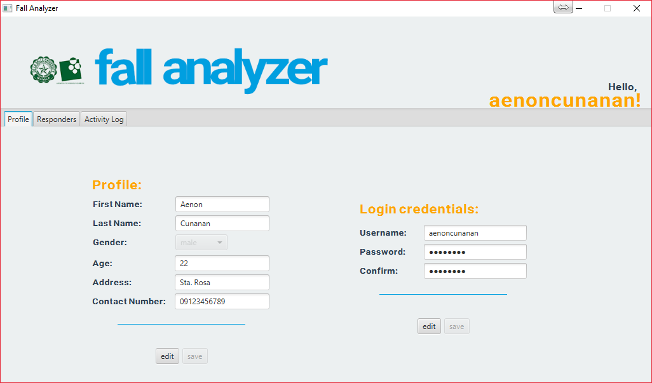

Figure 9: Profile Tab

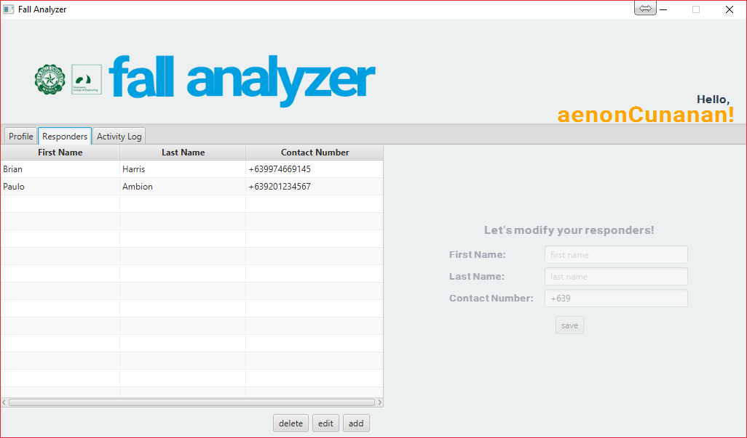

Figure 10: Responders Tab

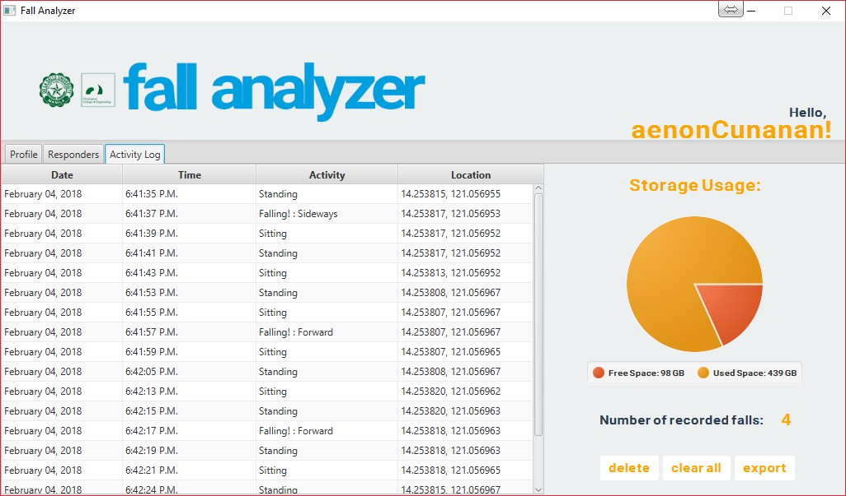

Figure 11: Activity Log

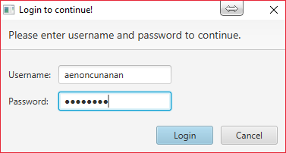

Figure 12: Prompt

Shown in Figures 9 to 11 is the explore window where the data records can be found. Figure 9 shows the profile tab which includes the name, gender, contact number, and address of the user. Responders tab can be seen in Figure 10, from which the responder’s details such as name, and contact number can be seen. On the next tab shown in Figure 11, the activity log where the activities and motions of the user can be found. These tabs from the explore window can be seen by all but only the user has the access to edit the recorded data. If the user wishes to modify some data, a prompt will show up as shown in Figure 12. The prompt will request the user’s username and password to continue the modification of the recorded data.

1. Estimated Work, Schedule and Budget

Table 1.2 Estimated Work and Schedule

|  |  |  |  |  |  |  |  |  |  |  |  |  |
| --- | --- | --- | --- | --- | --- | --- | --- | --- | --- | --- | --- | --- |
| **AMBION, P.M.** | **Month & Year** | | | | | | | | | | | |
| Task | 2017 - 2018 | | | | | | | | | | | |
| ENGPRJ1 (Term 3) | | | | ENGPRJ2 (Term 1) | | | | ENGPRJ3 (Term3) | | | |
| May | June | July | Aug | Sept | Oct | Nov | Dec | Jan | Feb | Mar | Apr |
| **Preparatory** | | | | | | | | | | | | |
| Topic Conceptualization, Brainstorming and Consultation |  |  |  |  |  |  |  |  |  |  |  |  |
| **Chapter 1 INTRODUCTION** | | | | | | | | | | | | |
| Background of the Study |  |  |  |  |  |  |  |  |  |  |  |  |
| Prior Studies |  |  |  |  |  |  |  |  |  |  |  |  |
| Objectives of the Study |  |  |  |  |  |  |  |  |  |  |  |  |
| Significance of the Study |  |  |  |  |  |  |  |  |  |  |  |  |
| Scope and Limitations |  |  |  |  |  |  |  |  |  |  |  |  |
| Description of the Project |  |  |  |  |  |  |  |  |  |  |  |  |
| **Chapter 2 REVIEW OF RELATED LITERATURE** | | | | | | | | | | | | |
| Studies Related to Proposed Topic |  |  |  |  |  |  |  |  |  |  |  |  |
| Synthesis |  |  |  |  |  |  |  |  |  |  |  |  |
| Adviser Consultation |  |  |  |  |  |  |  |  |  |  |  |  |
| **Proposal Defense** |  |  |  |  |  |  |  |  |  |  |  |  |
| **Chapter 3 CONCEPTUAL AND THEORETICAL FRAMEWORK** | | | | | | | | | | | | |
| Fall Detection |  |  |  |  |  |  |  |  |  |  |  |  |
| Pre, During and Post-Fall Detection |  |  |  |  |  |  |  |  |  |  |  |  |
| **Chapter 4 DESIGN CONSIDERATIONS** | | | | | | | | | | | | |
| Design and Consideration Paper |  |  |  |  |  |  |  |  |  |  |  |  |
| Methods of Research Used |  |  |  |  |  |  |  |  |  |  |  |  |
| Development of the functions of Accelerometers |  |  |  |  |  |  |  |  |  |  |  |  |
| Development of User Interface |  |  |  |  |  |  |  |  |  |  |  |  |
| Translation of MPU 6050 |  |  |  |  |  |  |  |  |  |  |  |  |
| Consultation to the Adviser |  |  |  |  |  |  |  |  |  |  |  |  |
| **Chapter 5 METHODOLOGY** | | | | | | | | | | | | |
| Chapter 5 Paper |  |  |  |  |  |  |  |  |  |  |  |  |
| GSM, GPS and RTC development |  |  |  |  |  |  |  |  |  |  |  |  |
| Development of Memory Function |  |  |  |  |  |  |  |  |  |  |  |  |
| Combination of Modules |  |  |  |  |  |  |  |  |  |  |  |  |
| Prototype Testing and Data Gathering |  |  |  |  |  |  |  |  |  |  |  |  |
| **Chapter 6 RESULTS AND DISCUSSION** | | | | | | | | | | | | |
| **Chapter7 COCLUSIONS, RECOMMENDATIONS, AND FUTURE DIRECTIVES** | | | | | | | | | | | | |
| Chapters 6 & 7 Paper |  |  |  |  |  |  |  |  |  |  |  |  |
| Thesis Defense |  |  |  |  |  |  |  |  |  |  |  |  |
| Submission of Final Paper |  |  |  |  |  |  |  |  |  |  |  |  |

*Continued on next page*

*Continued from previous page*

|  |  |  |  |  |  |  |  |  |  |  |  |  |
| --- | --- | --- | --- | --- | --- | --- | --- | --- | --- | --- | --- | --- |
| **CUNANAN, A.M.** | **Month & Year** | | | | | | | | | | | |
| Task | 2017 - 2018 | | | | | | | | | | | |
| ENGPRJ1 (Term 3) | | | | ENGPRJ2 (Term 1) | | | | ENGPRJ3 (Term3) | | | |
| May | June | July | Aug | Sept | Oct | Nov | Dec | Jan | Feb | Mar | Apr |
| **Preparatory** | | | | | | | | | | | | |
| Topic Conceptualization, Brainstorming and Consultation |  |  |  |  |  |  |  |  |  |  |  |  |
| **Chapter 1 INTRODUCTION** | | | | | | | | | | | | |
| Background of the Study |  |  |  |  |  |  |  |  |  |  |  |  |
| Prior Studies |  |  |  |  |  |  |  |  |  |  |  |  |
| Objectives of the Study |  |  |  |  |  |  |  |  |  |  |  |  |
| Significance of the Study |  |  |  |  |  |  |  |  |  |  |  |  |
| Scope and Limitations |  |  |  |  |  |  |  |  |  |  |  |  |
| Description of the Project |  |  |  |  |  |  |  |  |  |  |  |  |
| **Chapter 2 REVIEW OF RELATED LITERATURE** | | | | | | | | | | | | |
| Studies Related to Proposed Topic |  |  |  |  |  |  |  |  |  |  |  |  |
| Synthesis |  |  |  |  |  |  |  |  |  |  |  |  |
| Adviser Consultation |  |  |  |  |  |  |  |  |  |  |  |  |
| **Proposal Defense** |  |  |  |  |  |  |  |  |  |  |  |  |
| **Chapter 3 CONCEPTUAL AND THEORETICAL FRAMEWORK** | | | | | | | | | | | | |
| Fall Detection |  |  |  |  |  |  |  |  |  |  |  |  |
| Pre, During and Post-Fall Detection |  |  |  |  |  |  |  |  |  |  |  |  |
| **Chapter 4 DESIGN CONSIDERATIONS** | | | | | | | | | | | | |
| Design and Consideration Paper |  |  |  |  |  |  |  |  |  |  |  |  |
| Methods of Research Used |  |  |  |  |  |  |  |  |  |  |  |  |
| Development of the functions of Accelerometers |  |  |  |  |  |  |  |  |  |  |  |  |
| Development of User Interface |  |  |  |  |  |  |  |  |  |  |  |  |
| Translation of MPU 6050 |  |  |  |  |  |  |  |  |  |  |  |  |
| Consultation to the Adviser |  |  |  |  |  |  |  |  |  |  |  |  |
| **Chapter 5 METHODOLOGY** | | | | | | | | | | | | |
| Chapter 5 Paper |  |  |  |  |  |  |  |  |  |  |  |  |
| GSM, GPS and RTC development |  |  |  |  |  |  |  |  |  |  |  |  |
| Development of Memory Function |  |  |  |  |  |  |  |  |  |  |  |  |
| Combination of Modules |  |  |  |  |  |  |  |  |  |  |  |  |
| Prototype Testing and Data Gathering |  |  |  |  |  |  |  |  |  |  |  |  |
| **Chapter 6 RESULTS AND DISCUSSION** | | | | | | | | | | | | |
| **Chapter7 COCLUSIONS, RECOMMENDATIONS, AND FUTURE DIRECTIVES** | | | | | | | | | | | | |
| Chapters 6 & 7 Paper |  |  |  |  |  |  |  |  |  |  |  |  |
| Thesis Defense |  |  |  |  |  |  |  |  |  |  |  |  |
| Submission of Final Paper |  |  |  |  |  |  |  |  |  |  |  |  |

*Continued on next page*

*Continued form previous page*

|  |  |  |  |  |  |  |  |  |  |  |  |  |
| --- | --- | --- | --- | --- | --- | --- | --- | --- | --- | --- | --- | --- |
| **HARRIS, E.B.** | **Month & Year** | | | | | | | | | | | |
| Task | 2017 - 2018 | | | | | | | | | | | |
| ENGPRJ1 (Term 3) | | | | ENGPRJ2 (Term 1) | | | | ENGPRJ3 (Term3) | | | |
| May | June | July | Aug | Sept | Oct | Nov | Dec | Jan | Feb | Mar | Apr |
| **Preparatory** | | | | | | | | | | | | |
| Topic Conceptualization, Brainstorming and Consultation |  |  |  |  |  |  |  |  |  |  |  |  |
| **Chapter 1 INTRODUCTION** | | | | | | | | | | | | |
| Background of the Study |  |  |  |  |  |  |  |  |  |  |  |  |
| Prior Studies |  |  |  |  |  |  |  |  |  |  |  |  |
| Objectives of the Study |  |  |  |  |  |  |  |  |  |  |  |  |
| Significance of the Study |  |  |  |  |  |  |  |  |  |  |  |  |
| Scope and Limitations |  |  |  |  |  |  |  |  |  |  |  |  |
| Description of the Project |  |  |  |  |  |  |  |  |  |  |  |  |
| **Chapter 2 REVIEW OF RELATED LITERATURE** | | | | | | | | | | | | |
| Studies Related to Proposed Topic |  |  |  |  |  |  |  |  |  |  |  |  |
| Synthesis |  |  |  |  |  |  |  |  |  |  |  |  |
| Adviser Consultation |  |  |  |  |  |  |  |  |  |  |  |  |
| **Proposal Defense** |  |  |  |  |  |  |  |  |  |  |  |  |
| **Chapter 3 CONCEPTUAL AND THEORETICAL FRAMEWORK** | | | | | | | | | | | | |
| Fall Detection |  |  |  |  |  |  |  |  |  |  |  |  |
| Pre, During and Post-Fall Detection |  |  |  |  |  |  |  |  |  |  |  |  |
| **Chapter 4 DESIGN CONSIDERATIONS** | | | | | | | | | | | | |
| Design and Consideration Paper |  |  |  |  |  |  |  |  |  |  |  |  |
| Methods of Research Used |  |  |  |  |  |  |  |  |  |  |  |  |
| Development of the functions of Accelerometers |  |  |  |  |  |  |  |  |  |  |  |  |
| Development of User Interface |  |  |  |  |  |  |  |  |  |  |  |  |
| Translation of MPU 6050 |  |  |  |  |  |  |  |  |  |  |  |  |
| Consultation to the Adviser |  |  |  |  |  |  |  |  |  |  |  |  |
| **Chapter 5 METHODOLOGY** | | | | | | | | | | | | |
| Chapter 5 Paper |  |  |  |  |  |  |  |  |  |  |  |  |
| GSM, GPS and RTC development |  |  |  |  |  |  |  |  |  |  |  |  |
| Development of Memory Function |  |  |  |  |  |  |  |  |  |  |  |  |
| Combination of Modules |  |  |  |  |  |  |  |  |  |  |  |  |
| Prototype Testing and Data Gathering |  |  |  |  |  |  |  |  |  |  |  |  |
| **Chapter 6 RESULTS AND DISCUSSION** | | | | | | | | | | | | |
| **Chapter7 COCLUSIONS, RECOMMENDATIONS, AND FUTURE DIRECTIVES** | | | | | | | | | | | | |
| Chapters 6 & 7 Paper |  |  |  |  |  |  |  |  |  |  |  |  |
| Thesis Defense |  |  |  |  |  |  |  |  |  |  |  |  |
| Submission of Final Paper |  |  |  |  |  |  |  |  |  |  |  |  |

Table 1.3 Estimated Budget

|  |  |  |  |
| --- | --- | --- | --- |
| **Components and Parts** | **Basic Details** | **Significance of components to the Project** | **Price** |
| Genuino 101 | This is a 32-bit microcontroller, powered by Intel Curie microprocessor that has 196 kb flash memory and 24 kb sram with built-in Bluetooth LE and 6-axis accelerometer/gyro technology. (Intel, 2018) | This microcontroller will be used to detect and assess the motion and orientation of the user using its built-in accelerometer. | P 2,048.00 |
| GSM/GPS/GPRS/SMS SIM808 CROWTAIL  and Sim Card | This is a GSM and GPS two-in-one function module which is called Crowtail- SIM808. It is very small and based on the latest GSM/GPS module SIM808 from SIMCOM, it supports GSM/GPRS Quad-Band network and combines GPS technology for satellite navigation. It has high GPS receive sensitivity with 22 tracking and 66 acquisition receiver channels that will lets you add location-tracking, voice, and text. (Circuitrocks, 2018) | This GSM/GPS/GPRS module will be used to detect the GPS coordinate of the user. It has also GSM capabilities, so that we can send SMS message to the emergency hotline and family of the user, so that we can notify them that the user need help and assistance. | P 1,917.00  P 50.00 |
| SD card socket  Module and  SD card | This is an Arduino compatible module and SD card library could be used with this device. (Circuitrocks, 2018) | The SD card module will be used to read and write to the SD card to create a database. The database will be composed of data collected and the basic information of the user. | P 105.00  P 300.00 |

*Continued on next page*

*Continued form previous page*

|  |  |  |  |
| --- | --- | --- | --- |
| **Components and Parts** | **Basic Details** | **Significance of components to the Project** | **Price** |
| MPU6050 Accelerometer Module | This is an InvenSense MPU-6050 sensor that contains a micro electro mechanical system (MEMS) accelerometer and MEMS gyro in a single chip. It contains 16-bits analog to digital conversion hardware for each channel. It captures the x, y, and z channel at the same time. (Circuitrocks, 2018) | This module will be used to detect falling motions and the specific motions of the user. Together with the built-in accelerometer in the Arduino 101 module, acceleration and dynamics can be computed which can be used to analyze the said motions. | P 162.00 |
| Piezo Buzzer | This is a piezoelectric speaker or buzzer that uses the piezoelectric effect for generating sound. It is a d36 mm Mylar Cone 8ohms 0.5w (e-Gizmo Mechatronix Central, 2018) | This component will be used to alarm as it notifies the user when the device detects a falling motion or to alarm the user if the memory of the device is almost full. | P 22.00 |
| Push Button | This is a side tact switch SPST through hole 7x4mm package/image: 77008044. It causes a temporary change in the state of an electronic circuit only while the switch is physically actuated. (e-Gizmo Mechatronix Central, 2018) | This push button is used to terminate the process of the device on sending SMS to the responder recorded. | P 6.00 |
| 9v Rechargeable Battery | This is a 9-volt rechargeable battery with 300 mAh which can be charged into standard charger for 14-15 hours. | This battery will be used to power up the fall analyzer device. | P 493.50 |

*Continued on next page*

*Continued from previous page*

|  |  |  |  |
| --- | --- | --- | --- |
| **Components and Parts** | **Basic Details** | **Significance of components to the Project** | **Price** |
| 9v Battery Snap | This is a battery clip for 9v battery attachment with complete red and black power lines. (e-Gizmo Mechatronix Central, 2018) | This battery snap will be used for connecting the device to the 9v battery that will serve as a power source. | P 5.00 |
| Power Switch | This is a 6A 250V AC/10A 125 Ac Snap boat rocker switch (e-Gizmo Mechatronix Central, 2018) | This switch will be used in connecting the power source to the device. | P 15.00 |
| 300-ohm resistor | This is a 300-ohm resistor ¼W. (e-Gizmo Mechatronix Central, 2018) | This resistor will be used for controlling the voltage and current going to the LED | P 0.25 |
| Red LED | This is a 10-mm red and yellow light emitting diode. (e-Gizmo Mechatronix Central, 2018) | This LED will serve as a signal light for the device whether it is connected to the GPS and to give a signal of the device functionality. | P 6.50/pc |
| Yellow LED |

1. Overview

The background of the study, the related studies, the statement of the problem, the general and specific objectives, the significance of the study and the scope and limitations of the study was overviewed in this chapter. On Chapter 2, the compilation of previous studies can be seen. It is a collection of past studies and how those studies helped in assembling and formulating of this study. Chapter 3 shows the theories where this project was based. In this chapter, the theoretical background on how each part of the fall analyzer was made. Chapter 4 contains the design of the project. Chapter 5 enumerates the methods on how the prototype of fall analyzer has been made. Chapter 6 contains the result and discussion of the experiment. In here the experiment’s data and the evaluation of those data can be seen. Lastly, Chapter 7 has the conclusion and recommendation of the study.

Chapter 2

LITERATURE REVIEW

|  |
| --- |
|  |

LITERATURE REVIEW 40

2.1. Existing Work 41

2.2. Lacking in the Approaches 45

|  |
| --- |
|  |

1. Existing Work

For aged population, falls are dangerous for they can adversely affect health. (Li, Hanson, Stankovic, Barth, & Lach, 2009) Fracture, certain possibility to get coma, brain trauma, and paralysis are the most common injury in fall of an elderly. The high impact is the main source of injury at most fall situations. But sometimes the late medical salvage may worsen the situation. That means the faster the salvage comes, the less risk the elderly will face which makes the progress of technology brings more possibilities to help us protect the elderly (Wu, Zhao, Zhao, & Zhong, 2014).

Several kinds of fall detection methods have been developed or applied in our life. Most of the research on falls where accelerometers are used focus on determining the change in magnitude of acceleration. When the acceleration value exceeds a critical threshold, the fall is detected. These systems successfully detect falls with sensitivities greater than 85% and specificities between 88-94%. However, focusing on large acceleration only can result in many false positives from fall-like activities such as sitting down quickly and running. (Huynh, Nguyen, Tran, Nabili, & Tran, 2013).

Some fall detection algorithms also assume falls happen when the body lies prone on the floor which are less effective when a person’s fall posture is not horizontal, e.g. fall happened on stairs. Furthermore, previous studies used complex algorithms like support vector machine (SVM) and Markov models to detect the fall. However, accuracy of these systems has not been proven to be highly effective. They also use excessive amounts of computational resources and cannot respond in real time. In addition, fall activity patterns are particularly difficult to obtain for training systems. Unlike other previous researches, this project proposes using the accelerometer sensor to detect the falls for increasing the sensitivities and specificities of a fall detection system. Accelerometers can detect orientation and axis of movements as it is one of the feature of these technologies (Huynh, Nguyen, Tran, Nabili, & Tran, 2013).

***Fall detection:***

Existing fall detection solutions can be divided into two classes. The first class only analyzes acceleration to detect falls. A second class of solutions utilize both acceleration and body orientation information to detect falls (Li, Hanson, Stankovic, Barth, & Lach, 2009). The algorithm uses the accelerometer present in cellphones to monitor falls. If a fall is detected, the application automatically notifies predefined contacts (such as parents or emergency services) with the victim’s GPS coordinates shown on a map. (Kazi, Sikander, & Yousafzai, 2014)

When the subject falls, the acceleration is rapidly changing, and the angular velocity produces a variety of signals along fall direction. The lower and upper fall thresholds for the acceleration and angular velocity used to identify the fall are derived as follows:

* + - Lower fall threshold (LFT): the negative peaks for the resultant of each recorded activity are referred to as the signal lower peak values (LPVs). The LFT for the acceleration signals are set at the level of the smallest magnitude lower fall peak (LFP) recorded.
    - Upper fall threshold (UFT): the positive peaks for the recorded signals for each recorded activity are referred to as the signal upper peak values (UPVs). The UFT for each of the acceleration and the angular velocity signals were set at the level of the smallest magnitude UPV recorded. The UFT is related to the peak impact force experienced by the body segment during the impact phase of the fall (Huynh, Nguyen, Tran, Nabili, & Tran, 2013).

Like every other past studies, accelerometer and gyroscope have limited abilities to measure a fall. All past algorithms involving these two components, had a good detection rate for actual falls, and had low false negatives except in the case of jumping onto a walking position in a bed or running. (Kazi, Sikander, & Yousafzai, 2014)

***Transmission***

When a fall has certainly occurred, there is still one false positive that remains to be accounted for, that is if a user accidentally falls and can still manage to stand up or simply in cases where the device can call the incident a false alarm. To account for this, a 10-second ‘grace period’ has been added to the device for the user where the device delays sending a text to a responder or the user can choose to cancel altogether. If the alarm is not cancelled within a pre-specified time, the device will send the persons GPS coordinates with a message to predefined people via GSM. (Kazi, Sikander, & Yousafzai, 2014)

***Data acquisition***

In the hardware part, microcontroller handles the acquisition of accelerometer data, which captures UTC time using an additional discriminator connected to the GPS receiver module and merges these data for transmission via Bluetooth module. To communicate with these modules, the microcontroller uses communication protocol for accelerometer module and UART interface for GPS and Bluetooth® modules, respectively. Microcontroller program codes were written and compiled with Proton IDE software (Gurkan, Gurkan, Dindar, Akpmar, & Gulal). All data can be logged to memory card for responder/s acquisition.

1. Lacking in the Approaches

Table 2.1 Lacking Approaches

| **Existing Work** | **Lacking Approaches** |
| --- | --- |
| Accurate, Fast Fall Detection Using Gyroscopes and Accelerometer-Derived Posture Information (Li, Stankovic, Hanson, Barth, & Lach, 2009) | This study combines the use of gyroscope and accelerometer to create a device that can detect fall which is unlikely to other studies that uses accelerometer that isolates falls from activities of daily living (ADL). This study sets two categories that divides ADL, the static and dynamic postures. Motions such as standing, sitting and lying does not limit our study. Unlikely, our study has a sub feature of determining a dynamic motion such as walking. Using the same modules, the accelerometer and gyroscope, determines whether the user is subjected to fall even when they are in static motion like sitting, standing and lying so as the dynamic motion like walking.  This study also uses linear acceleration and angular velocity to determine whether the motion transition is intentional and use it to determine a sudden fall. Our study however, uses time difference of previous position and current position when the user has fallen. Using this simple method, intentional fall can be differentiated with sudden fall and it uses a simple computational algorithm that can help the device to compute data easily compared to this study. |
| A Wireless Body Area Network of Intelligent Motion Sensors for Computer Assisted Physical Rehabilitation (Jovanov, Milenkovic, Otto, & De Groen, 2005) | The focus of this study is to create a wireless sensor that can be used to detect multi-tier telemedicine system that can be implemented by the aid of computer-assisted physical rehabilitation applications and ambulatory monitoring. Our study focuses on the same concept but specialized on the fall detection of patient in which the device to detect fall does not need the continuous attendance of a computer-based monitor nor the attendance of a person that will monitor the monitoring capability of device to monitor the overall medical performance of the user.  The communication system of this study that gives notification to the responder, and the ability to send the recorded data from the device rely on the use of internet, while our study submits |

*Continued on next page*

*Continued from previous page*

| **Existing Work** | **Lacking Approaches** |
| --- | --- |
|  | notification to the responder using SMS and the recorded data of the user before, during and after the fall can be access directly through the device. This means the absence of internet does not interfere to the notification ability of the system of our project, especially the design was based from the Philippine settings in which internet connection is not reliable. |
| Enhancing the Quality of Life Through Wearable Technology (Park & Jayaraman, 2003) | Wearable technology is the focus of this study. It provides a wearable medical device that detects medical issues of user and give information to the attending guardian or doctor. It includes a motherboard that is based on fabric and was created to be a smart wearable shirt. The wearable characteristic of this study was achieved, and, in our study, we tried to create a device that can be carried by the user and can detect fall emergency that can also give details of the pre-fall, during fall and post-fall events of the user to the responder. The user-friendly feature, and the “can be carried device” characteristic can be considered the wearable feature of the device. Also, the information of the user as they use the device in our study was enhanced by the location detector, fall detector and the ability to send a message to a responder during a fall of the said device. |
| Development of a Wearable-Sensor-Based Fall Detection System (Wu, Zhao, Zhao, & Zhong, 2014) | This study used the accelerometer to identify, analyze and recognize fall. It comes together with a GPS/GSM module that is used only when the user is outdoor. Through these devices, the location of the user when fallen can be identified and can be used to notify the responder to give an immediate action for the incident, also, our study also uses accelerometer. Though through the results of other studies, it was proven that the combination of accelerometer and gyroscope increases the efficiency of identifying fall, in this study vector analysis was used in accelerometer to allow to have the module a better range of identifying motions. Using the tri-axial accelerometer, the previous activities of the user such as walking, standing or sitting can also be known before the user has fallen. On the other hand, the use of GPS/GSM module in our study was maximized. The location of the user can also be identified even when he/she is indoor and not just outdoor. An SMS is being sent in case the user has fallen anywhere and anytime to the registered responder from the module itself. |

*Continued on next page*

*Continued from previous page*

| **Existing Work** | **Lacking Approaches** |
| --- | --- |
| Posture and Movement Classification: The Comparison of Tri-Axial Accelerometer Numbers and Anatomical Placement (Fotune, Lugade, & Kaufman, 2014) | The placement of tri-axial accelerometers on to the body was studied in this project. Three areas of the body were used to identify the most accurate results that an accelerometer can give. In this study, the waist, thigh and ankle were tested differently. As a result, for a single accelerometer, the thigh part is the best area that can give the better accurate result for the accelerometer, however, for two accelerometers, the combination of waist-thigh gives the most responsive and accurate results among other areas of the body. In our study, waist-thigh area is used to place the accelerometer and two accelerometers were also used. The combination of the built-in accelerometer from the genuino 101 and another accelerometer, clearly identifies the static and dynamic motion of the user through analyzing its vector component. |
| Fall Detection System Using Combination Accelerometer and Gyroscope (Huynh, Nguyen, Tran, Nabili, & Tran, 2013) | This study investigates the methodology to identify falls from normal Activities of Daily Living (ADLs). In this study, a wireless sensor system, based on accelerometer and gyroscope, is placed at the center of the chest to collect real time fall data. Experiment protocols consisting of four types of fall such as forward, backward and sideward (right and left) falls along with normal gait. (Huynh, Nguyen, Tran, Nabili, & Tran, 2013). Our study also identifies the direction of fall using the combination of two accelerometers, but the location of these modules was not placed on the chest rather on the waist and thigh as it was the best area to locate the sensors based from the other studies that concerns the detection of fall and ADLs. In addition, the location on where the user has fallen is being identified in our study and in such case a notification system is activated via GSM that gives notification to the registered responder in the module. |
| Fall Detection Using Single Tri-Axial Accelerometer (Kazi, Sikander, & Yousafzai, 2014) | This study uses a single tri-axial accelerometer that is a mobile phone-based system which implements a fall detection algorithm using a mobile phone’s built-in accelerometer which can detect falls with the victim’s GPS coordinates displayed on the map for timely delivery of medical help. (Kazi, Sikander, & Yousafzai, 2014). |

*Continued on nect page*

*Continued from previous page*

| **Existing Work** | **Lacking Approaches** |
| --- | --- |
|  | Our study is as much as the same with this, it can also detect fall using a tri-axial accelerometer. The notification system also identifies the predetermined responders in case of fall together with the location of the user using GPS coordinates. In addition, our study also identifies and differentiate motions such as static and dynamic from fall. Motions such as standing, sitting, lying and walking can also be known in our study and during the response of the responder in such incident of fall, the previous activity of the user can be identified and be used to further evaluation of the situation. |
| Wireless 3-Axis Accelerometer System for Measuring of Structural Displacement (Gurkan K. , Gurkan, Dindar, Akpinar, & Gulal, Engin, 2014) | This study presents the design of a 3-axis acceleration measurement system that can Coordinate Universal Time (UTC) time-stamping captured from Global Positioning System (GPS) receiver module. Acquired 3-axis acceleration data and UTC are transferred via Bluetooth protocol and developed software which enables monitoring and recording UTC and acceleration data on PC, respectively. (Gurkan, Gurkan, Dindar, Akpinar, & Gulal, Engin, 2014). This study uses UTC to record time and GPS to analyze displacement combined with the help of acceleration to identify displacement of user. These combined project results to an acceptable result but with a huge delay due to the complications of calculations. In our study, time and location can be identified by the help of GPS module while displacements or the body movement of user and the body orientation is being analyzed using the two tri-axial accelerometers. Both sets of modules aims to identify the displacement, , time and body orientation but our study enhances the delay of this study. |

CHAPTER 3

THOERETICAL CONSIDERATIONS

CHAPTER 3 51

THOERETICAL CONSIDERATIONS 51

3.1 Summary 53

3.2 Fall Detection 53

3.2.1 Motion Detection and Direction of Fall 53

3.2.2 Location of the User 54

3.2.3 Alert System 54

3.2.4 Graphical User Interface (GUI) 54

3.2.5 Sections of the Body 55

3.2.6 Trip, Stumble and Fall 55

3.2.7 Vector Analysis of Fall 56

3.3 Pre, During and Post Detection of Fall 57

3.3.1 Pre-fall Detection 57

3.3.2 During the fall Detection 57

3.3.3 Post Fall Detection 57

* 1. Summary

In this chapter, the hardware and software consideration in making the fall analyzer device can be seen. This chapter explains the parts and functions of fall analyzer device.

* 1. Fall Detection

To detect fall, instruments and devices are created to identify if the observed object undergoes the action of fall. In human detection of fall, considerations such as the direction of fall, the sections of the body that can help to consider fall, the types of fall and the way how to analyze fall must be consider.

* + 1. Motion Detection and Direction of Fall

The orientation of the fall is one of the components on analyzing fall. The object’s fall direction whether it is falling or have fallen in the directions such as forward, backward or sideward: right or left, is an important factor to identify fall. With the use of the triaxial-accelerometer, the direction of fall can be identified. The tri-axial accelerometer can acknowledge orientations with respect to the earth’s gravity.

Specific motions can also be acknowledged by this device. Static motions such as sitting and standing and dynamic motions such as walking and falling are motions that this device can evaluate. Using the same module, the accelerometer can measure motions. Static and dynamic motions can be recognized by the accelerometer thru analyzing the consistency and rapidness of the changes in motions.

* + 1. Location of the User

The location of the user can be known using the GPS module which is included in this device. The user’s location can is being recorded each time as the device is together with the user. After the fall, the coordinates of the user where s/he has fallen is included on the data to be sent to the defined responder/s so that as the responder/s receives the information, the location of the user can be easily located. Using the ability of the GPS module to identify the exact coordinate, time and date, added information as such can be helpful to the responder in dealing with the fall.

* + 1. Alert System

Using the GSM module, alert system via SMS is being implemented. At the moment the user has fallen, and the device recognize the fall, using the said module, information and notification alert will be sent to the defined responder/s. On the other hand, when the user has fallen and chooses not to initiate the alert system, it can be override by pressing a specific button that cancels the alert. This is done to avoid false alarm and to give the user a choice whenever the fall does not result to a heavy damage.

* + 1. Graphical User Interface (GUI)

The GUI makes the personalization setting or initiating of the device which includes the information of both the use and responder as well as the retrieval of recorded activities or motions before, during and after the fall easy. With the use of the GUI, the initiating and retrieval became user friendly in which data recorded can be easily found and understand easily as well.

* + 1. Sections of the Body

Another factor to consider in fall detection is the sections of the body. This must be considered to identify in which part of the body does the sensors can better detect motions such as walking, sitting, standing, lying and most importantly falling. To detect fall, sensors are introduced into specific areas of the body, particularly the waist and hip. Through these parts of the human body, motions mentioned above can be easily analyze because of the specific movement that these two creates whenever the subject is moving.

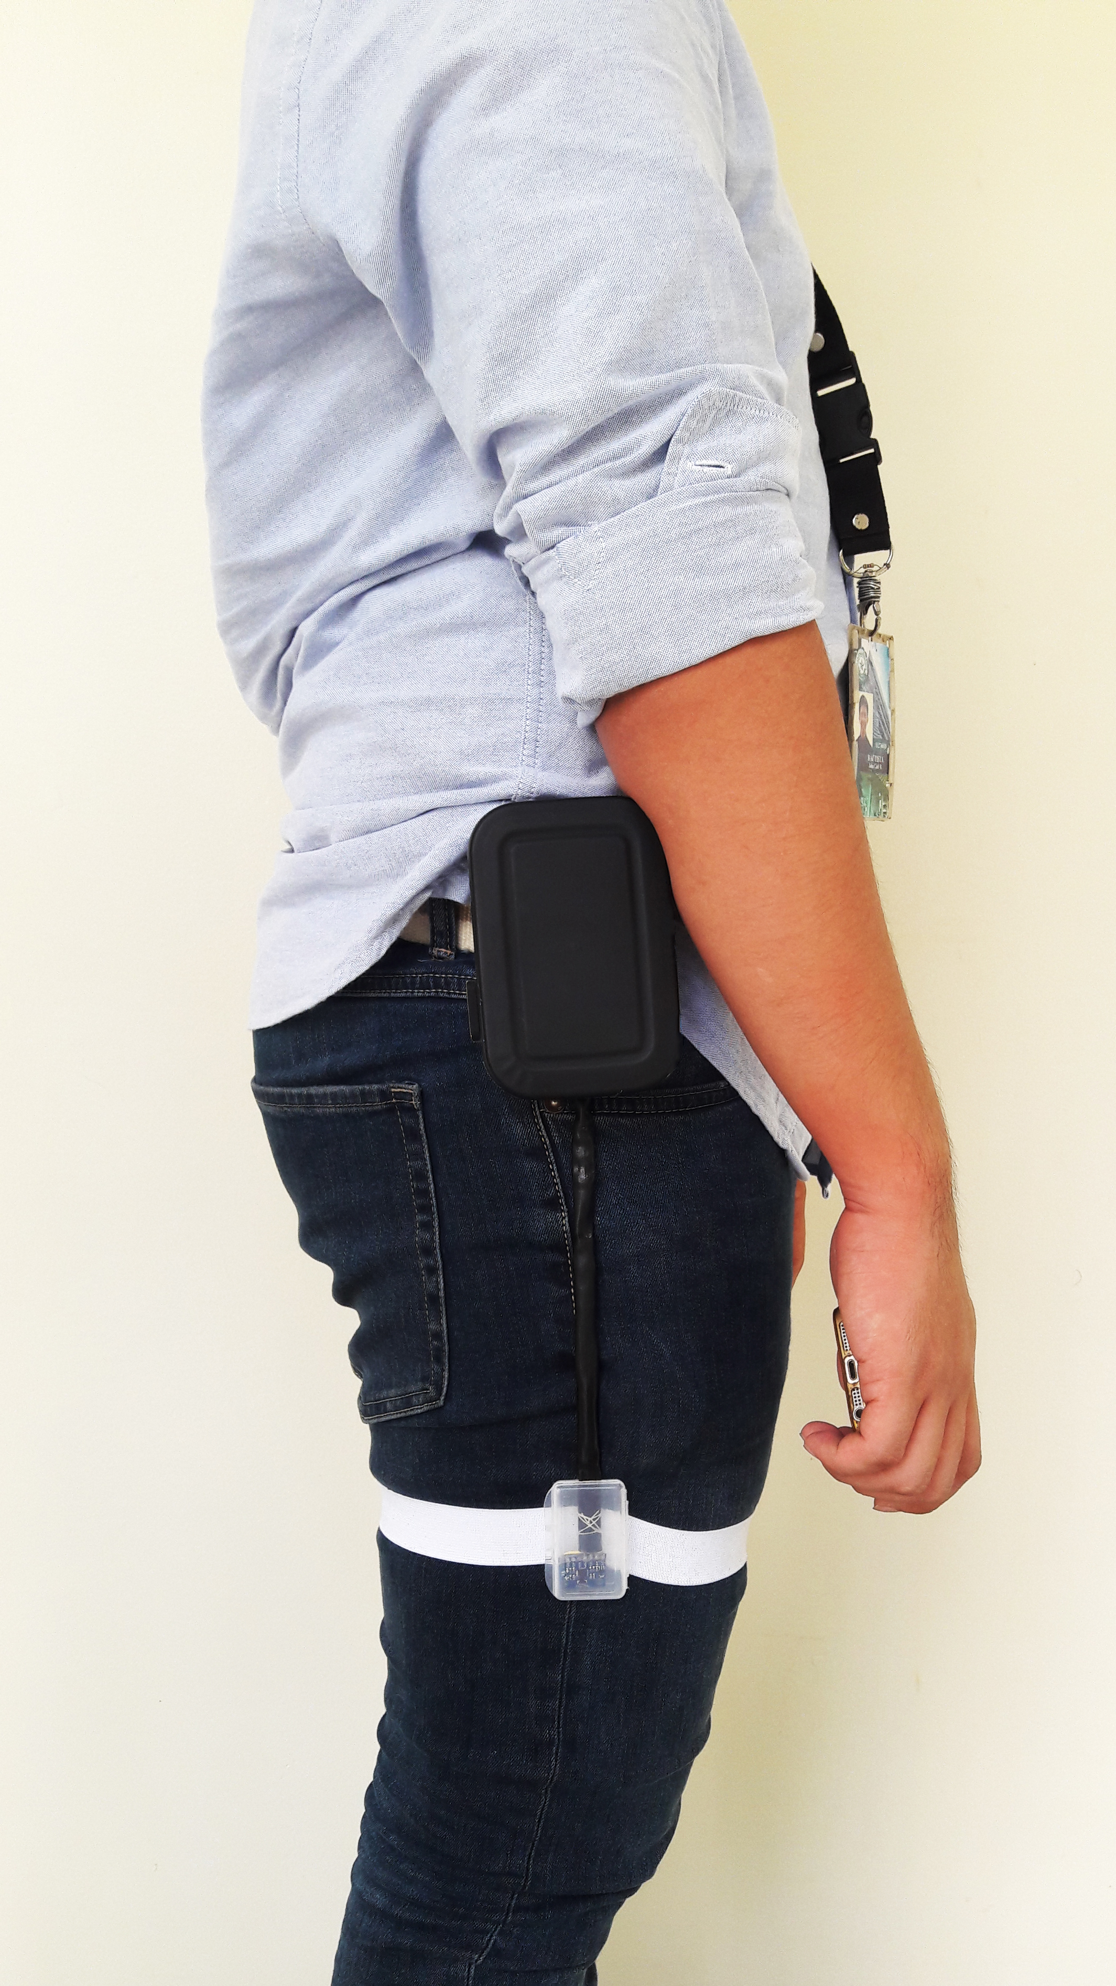

Figure 13: Device on the user

* + 1. Trip, Stumble and Fall

In many descriptions, fall can be defined as the moment of being trip, stumble, or fall. The device created to recognize fall detects all these descriptions if the subject fall flatly on the ground after such events. Generally, those descriptions mentioned above became a sub-definition of fall. Tripping and stumbling cannot be recognized if fall will not occur after those scenarios.

* + 1. Vector Analysis of Fall

From the sensors data, not only the direction of fall or fall itself will be analyzed. Through vector analysis of the data, other motions such as standing, sitting walking and lying will also be analyzed as a sub-feature of the device. The magnitude of acceleration follows (A), where “a”stands for the acceleration while “x, y and z” are values detected by the tri-axial accelerometer

Vector of cosines (B), are used to detect walking. The angles are used to determine the difference of the wideness of the swing of the leg during the said motion. As two types of motions has been categorized as static and dynamic motions where they are defined as motions that are in constant pattern and motions that are rapidly changing respectively, averaging algorithm (C) is needed to accurately predict and determine static motions in which will be the basis in identifying dynamic motions as well. Lastly errors must be computed (D) to determine the reliability of the measured data.

|  |  |
| --- | --- |
|  | (A) |
|  | (B) |
|  | (C) |
|  | (D) |

* 1. Pre, During and Post Detection of Fall

The device will analyze data before, during and after the fall happens. This will be recorded and will be used to analyze data

* + 1. Pre-fall Detection

On the pre-fall evaluation, the device will analyze the movement of the user before the fall happens. This movements can be classified as standing, walking sitting and lying. These data can be used as a sub-feature of the device and can be use by the responder/s to know the previous activity of the user before the fall happens.

* + 1. During the fall Detection

The device will record the time, location and orientation of the subject when they fall. This data will be stored into the database which will be accessible to the responder/s and the user.

* + 1. Post Fall Detection

After the fall, the device will send emergency messages to the responder/s that are recorded in the database. The device will send the location and of the user where the subject has fallen and the time they fall respectively.

CHAPTER 4

DESIGN CONSIDERATION

DESIGN CONSIDERATION 56

4.1 Summary 57

4.2 Development of Fall Detector 58

4.2.1 Fall Analyzer and Motion Detection Using Accelerometers 61

4.3 Languages Used 65

**__________________________________________________________________**

* 1. Summary

This chapter discusses the consideration on making the design of fall analyzer. This chapter contains the discussion on the software and hardware that was used in creating the fall analyzer device.

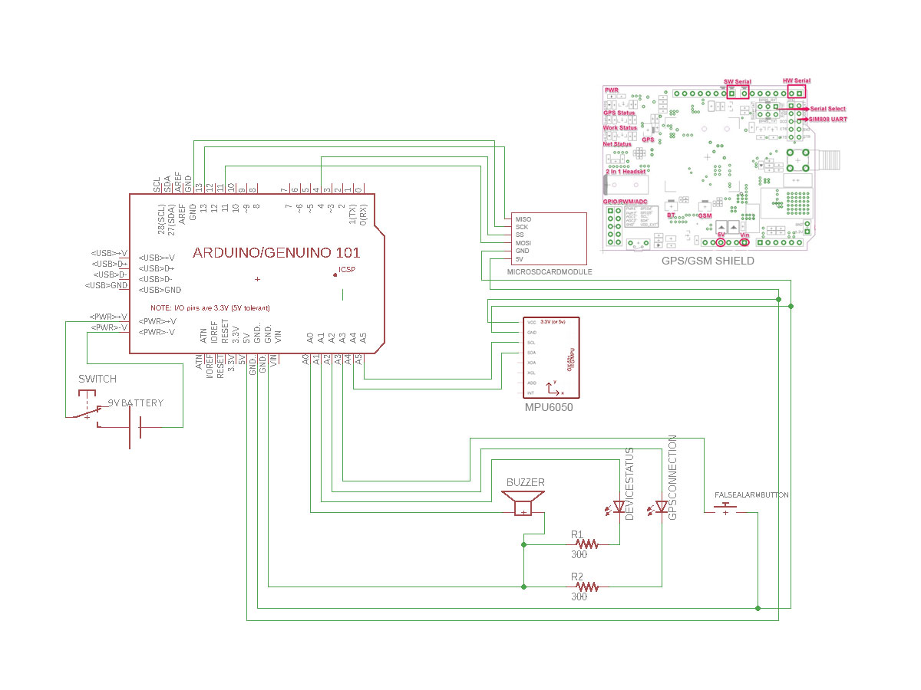

Figure 14: Schematic Diagram of the Device

* 1. Development of Fall Detector

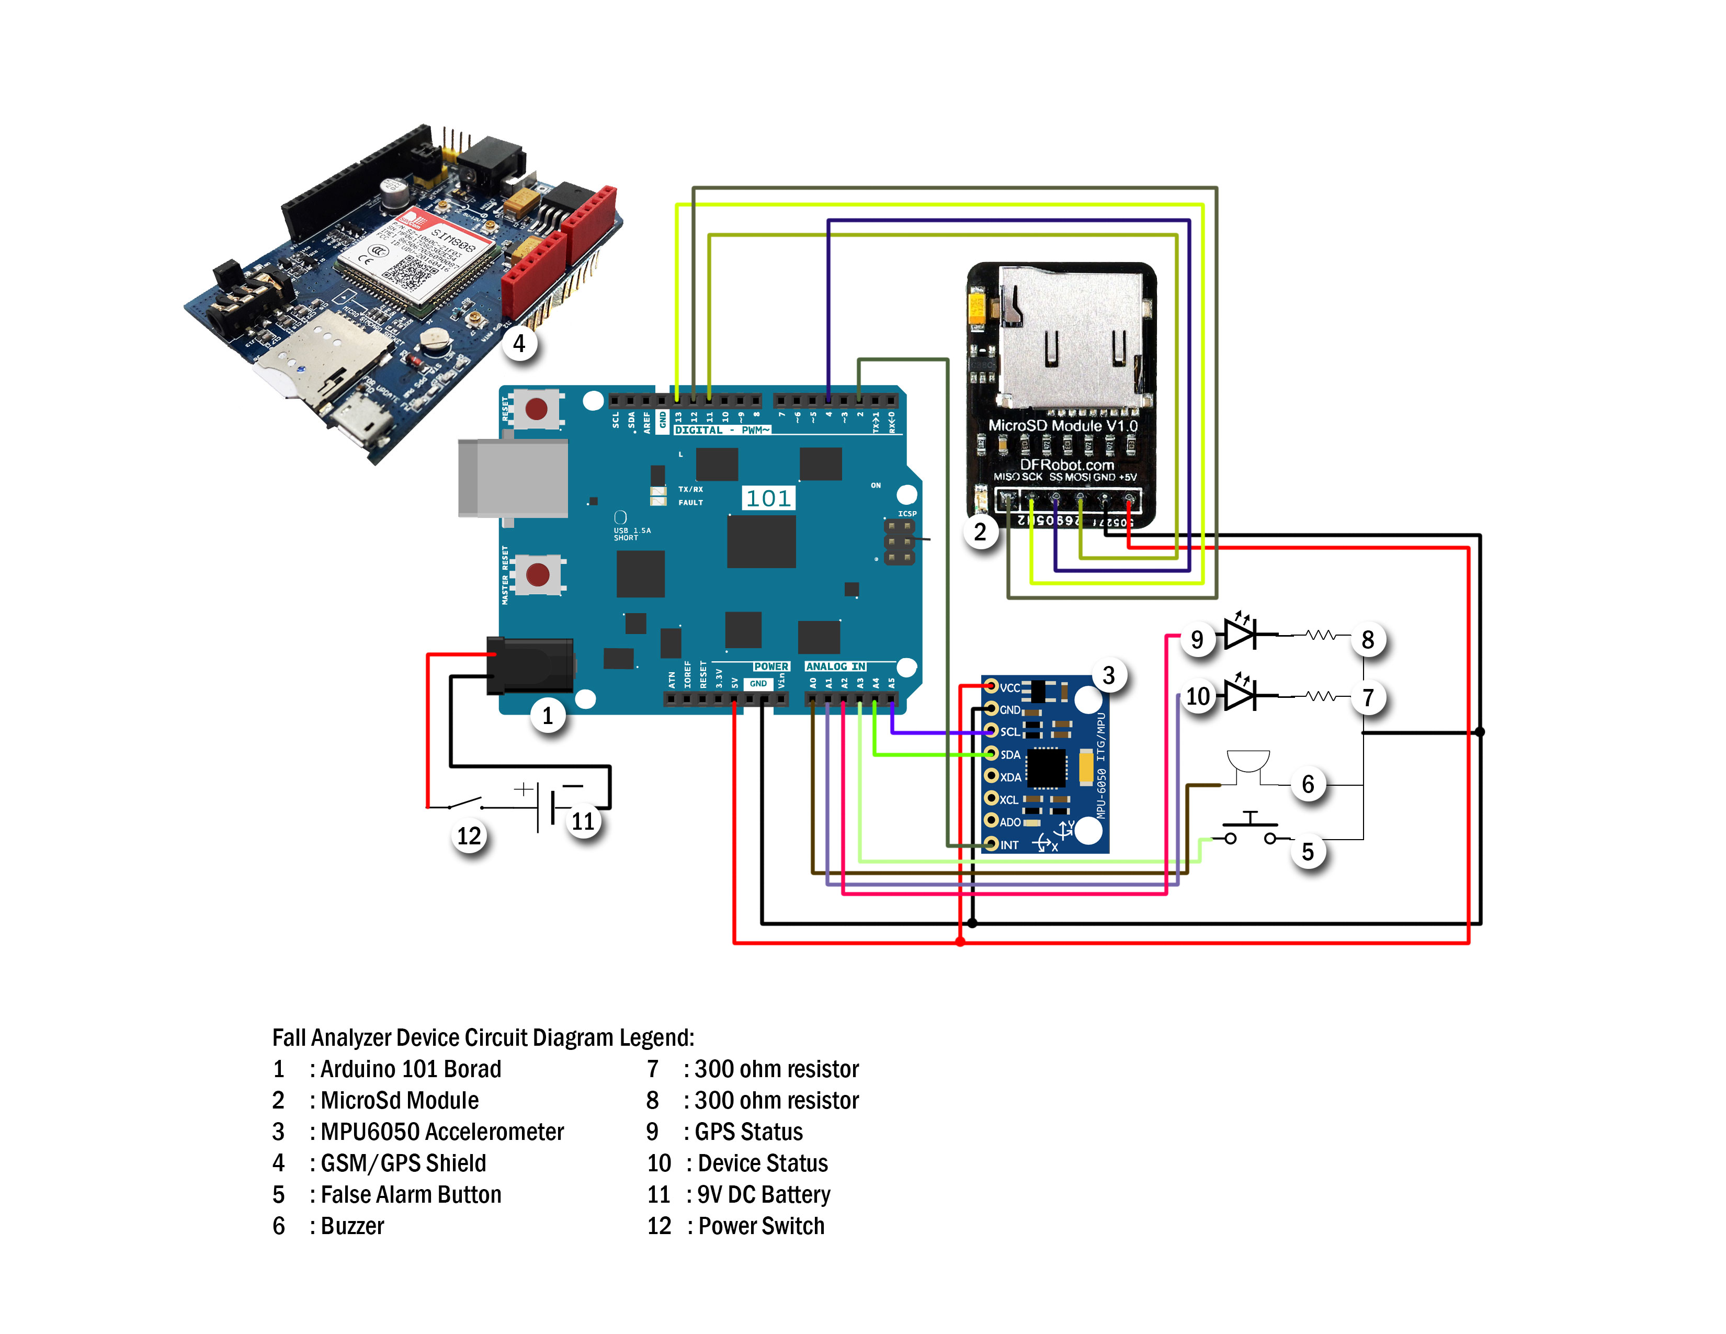

Figure 15: Fall Analyzer Circuit Design

In Figure 14, the design of fall analyzer device is shown. It is composed of the combined modules such as Arduino 101 board, MicroSD Card Module, MPU6050 Accelerometer, GSM/ GPS Shield, false alarm button, buzzer, and power module.

From Figure 14, the legends are as follows: (1) Arduino 101 board, (2) MicroSD Module, (3) MPU6050 Accelerometer, (4) GSM/GPS Shield, (5) False Alarm Button, (6) Buzzer, (7) & (8) 300 Ohm resistor, (9) GPS status, (10) Deice status, (11) 9V DC Battery and (12) Power switch.

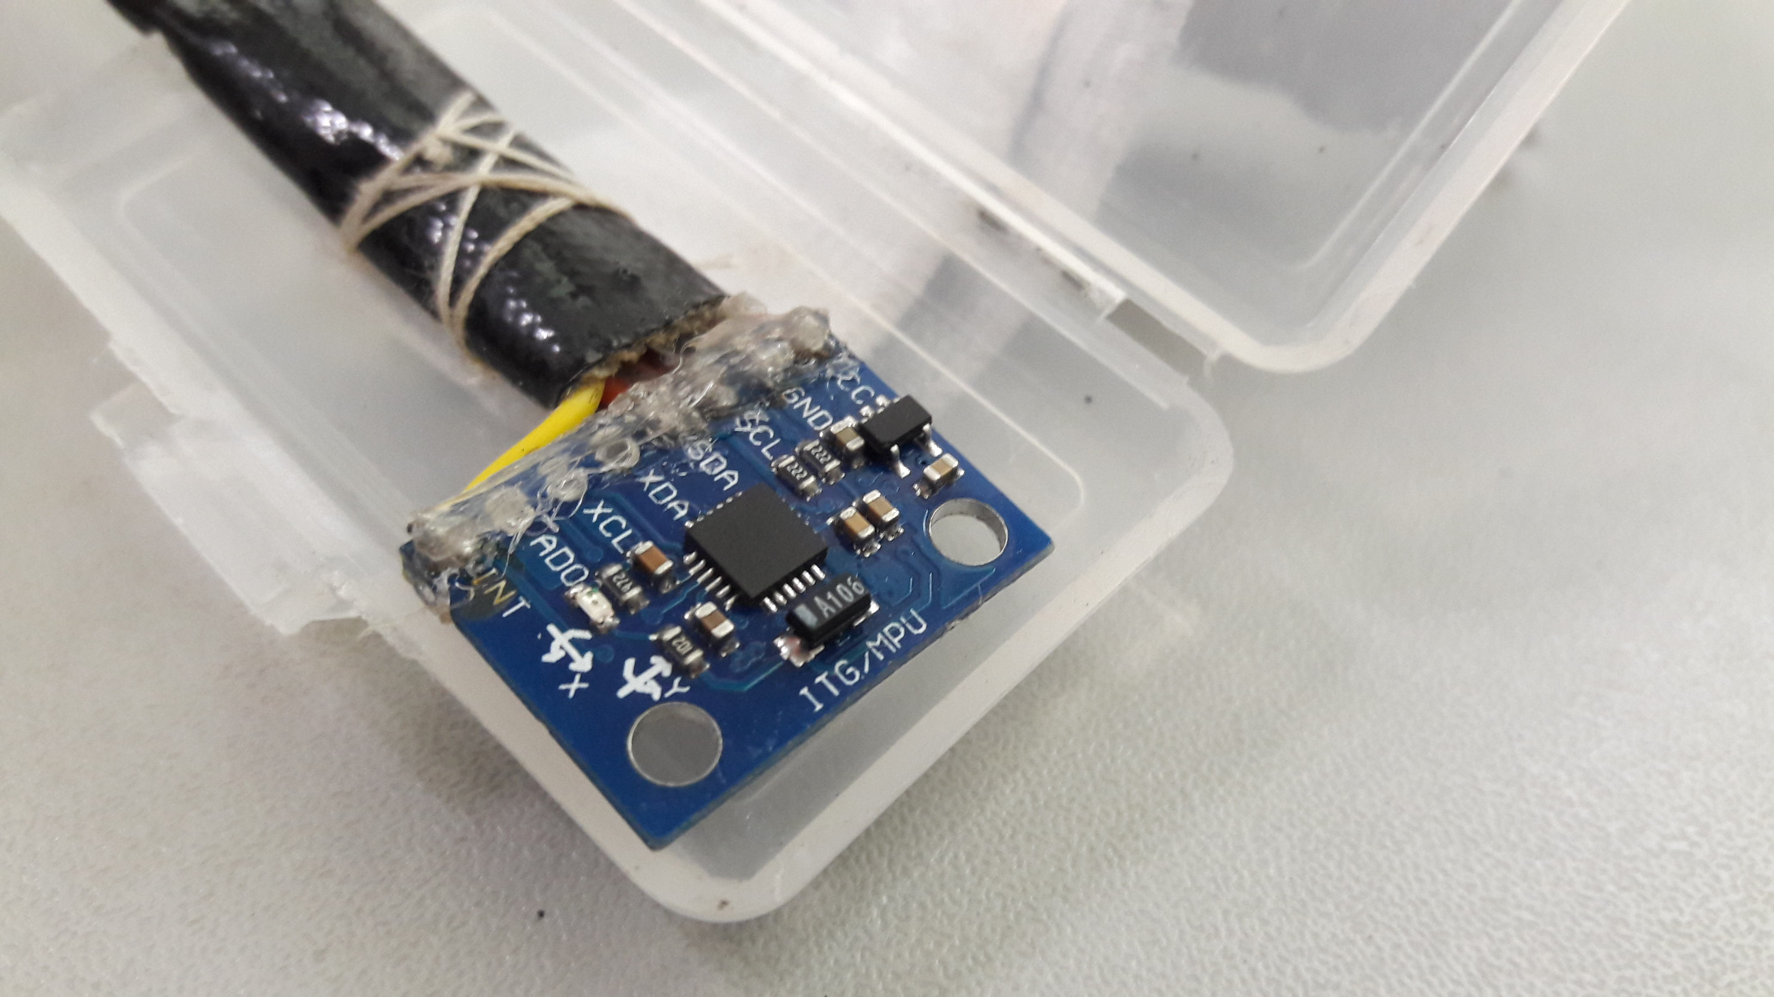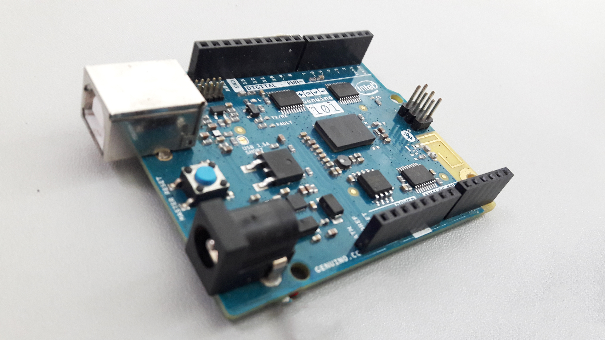

Figure 16: External Accelerometer and Arduino 101

Figure 16 shows the MPU6050 accelerometer and it is connected to the Arduino 101 with the connection as follows: Collector Supply Voltage (VCC) pin uses 5v pin of the Arduino and ground wiring is connected to GND pin. The clock line (SCL) is connected to A5 while the data line (SDA) is to A4 and Interrupt Pin (INT) is to D2.

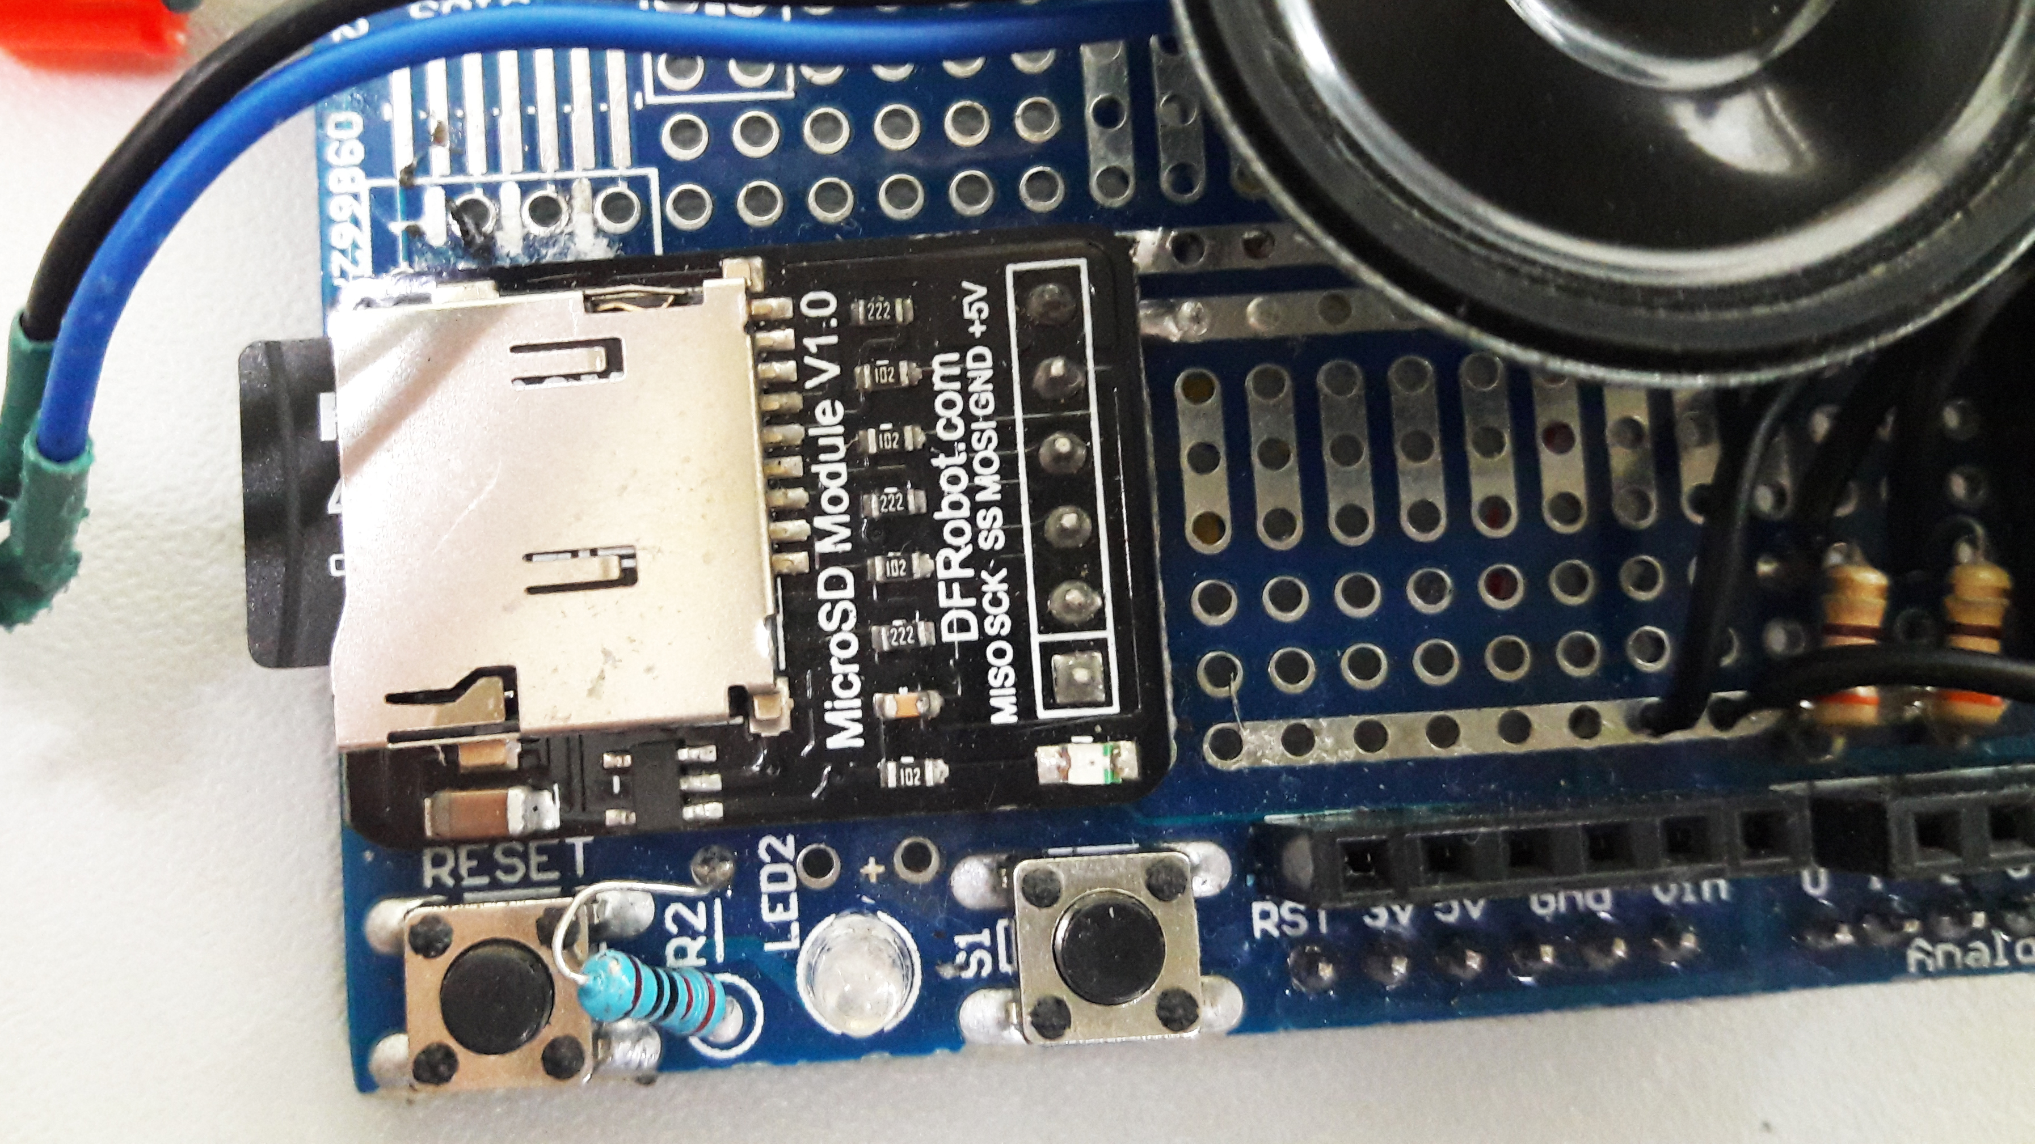

Figure 17: MicroSD Card Module

The MicroSD Module, Figure 16, is also connected to the Arduino with the connection as follows: Master In Slave Out pin (MISO) is connected to D12, System Clock (SCK) to D13, Slave Select (SS0 to D4, Master Out Slave In (MOSI) pin to D11 with ground to GND and VCC to 5v.

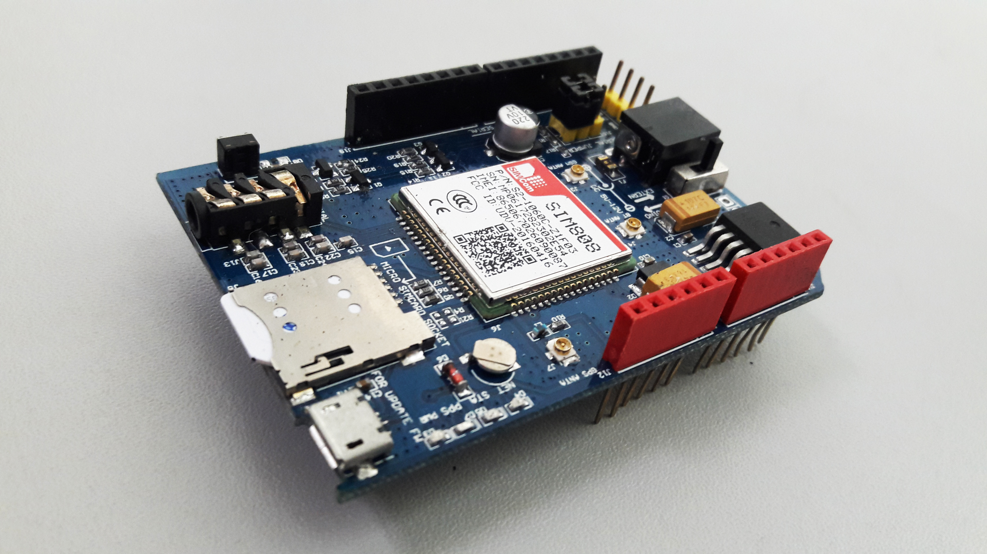

Figure 18: GPS/GSM Shield

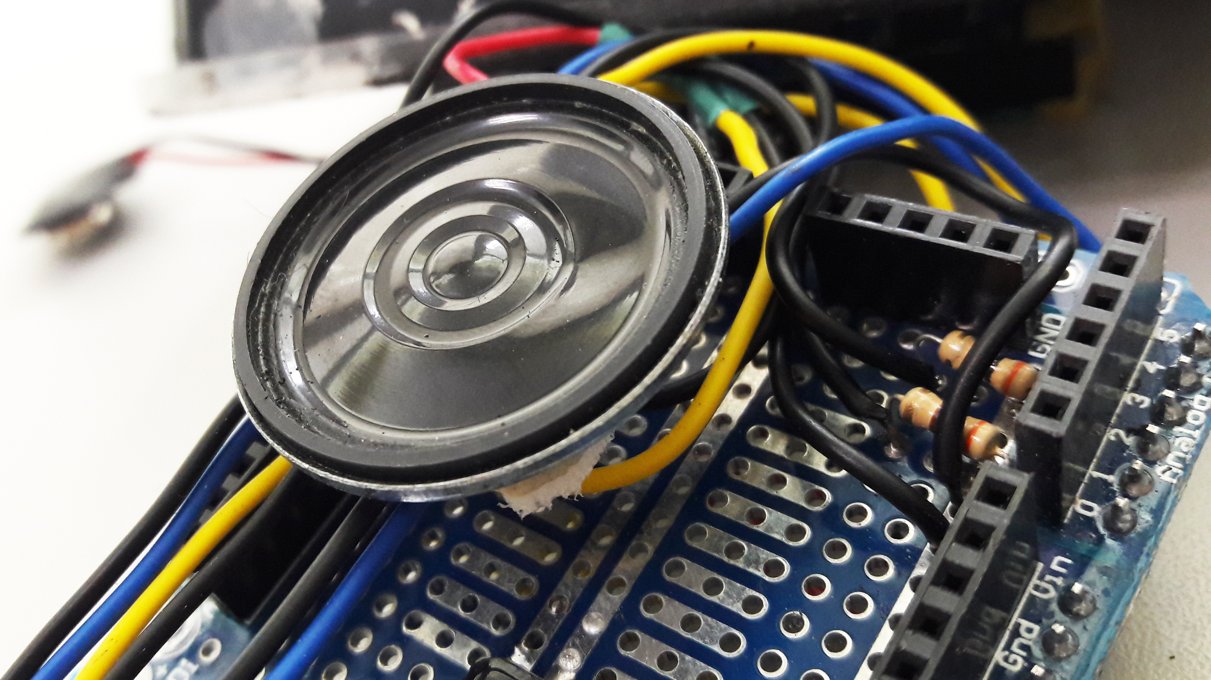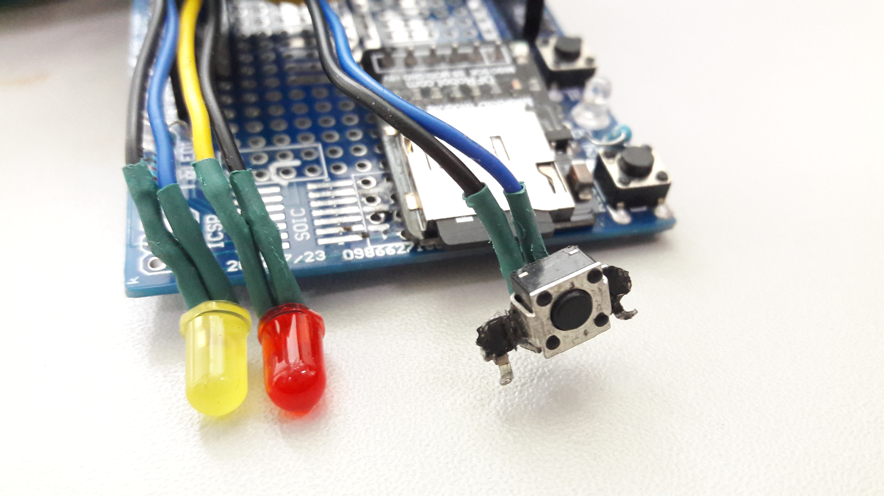

Figure 19: Buzzer, LEDs and Override Button

The GSM Shield in Figure 17, is stacked to be connected to Arduino while the Buzzer’s ground is connected to the Arduino’s GND pin and the positive pin of the buzzer to A0 pin of the Arduino. The device status and GPS status indicator using Light Emitting Diode (LED) and false alarm button are connected to the Arduino’s A1, A2 and A3 respectively while the ground the three components are connected to GND pin of the Arduino.

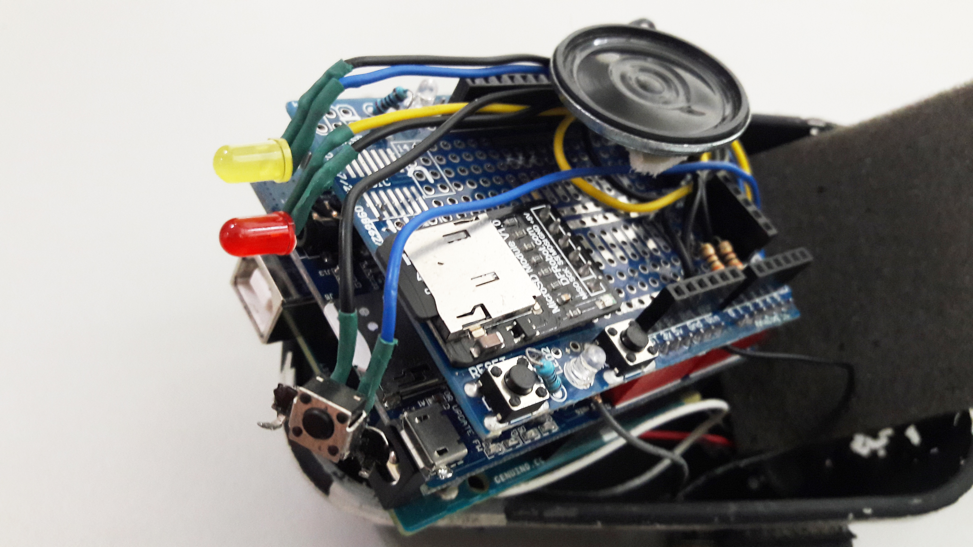

Figure 20: Device Proper

* + 1. Fall Analyzer and Motion Detection Using Accelerometers

Fall can be analyzed by the help of the built-in accelerometer from the Arduino 101, together with the MPU6050 accelerometer. These accelerometers can measure both static (gravity) and dynamic (motion or vibration) accelerations. (Safran Colibrys SA, 2018). Accelerometers was used to analyze the acceleration of the user so as the direction of the movement. Accelerometers are placed on the hip and the thigh of the user. The changes of the values from the result of the movement of the user with the help these accelerometers are computed which was used to identify and recognize whether the user moves statically, dynamically or if the user has fallen. On the other hand, as the user fell, the direction of the fall whether the user fell backwards, sideways or forward was also been analyzed by the built-in accelerometer from the Genuino 101.

From Figure 15 and 16, the flow chart on how the accelerometer works can be seen. The flow chart discusses the flow on how the accelerometer analyze the movements sequentially. The first step is to store the current y-vector to a previous y-vector container. Then get the new accelerometer inputs. The new inputs will be used to get the magnitude of the accelerations from x, y, z axis. After getting the magnitude, the percentage error between the current and previous values will be calculated. If the error is greater than 1.5%, the magnitude of the current value will become the previous value because there is no consistency, meaning, it is in dynamic motions like walking and falling. Else, it is in static motions like standing, sitting, or lying.

If it is in Dynamic motion, the difference between the current and previous angle of the y-vector will be calculated to determine if the magnitude error is greater than the gravity magnitude. If there is greater force than the gravity acting on the user, the device will check if it is lying position, if yes, the device will set the motion as forward, backward, or sideward fall. If no, the difference angle will be checked if it is in the walking angle range. It will then also check if the acceleration for walking is met. If the two parameters were satisfied, the device will set the motion as walking. If not, the current and previous value will be averaged and will be equal to the new previous value because the error is very minimal that makes it a static motion.

If it is in Static motion, it will check whether the inputs are equal to the standing, sitting, or lying position. If it matches one of the three (3) possible position, it will set the orientation as one of them, else, it will set the orientation as unknown.

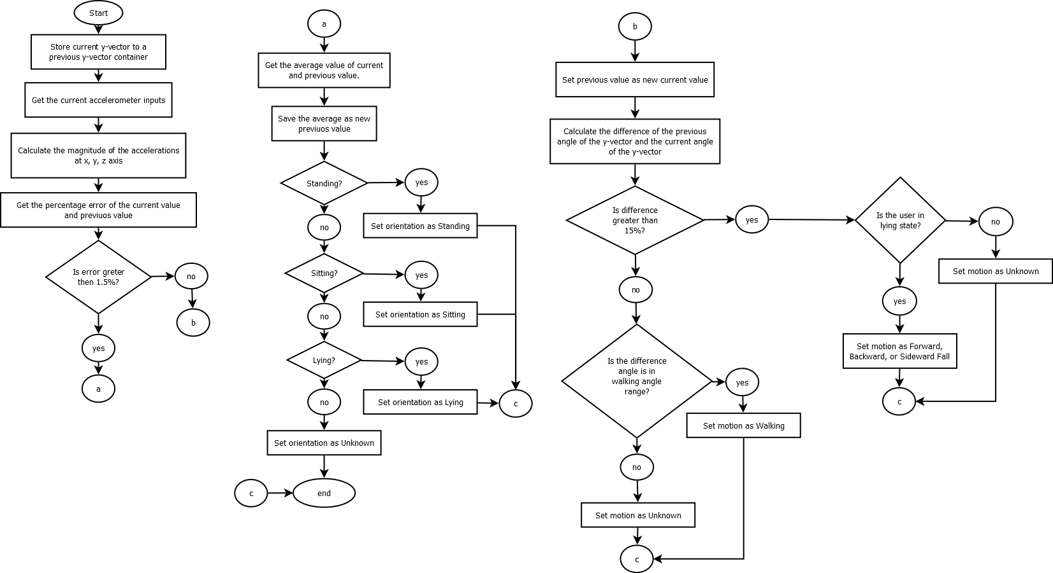

Figure 21: Input Analyzation flowchart (a)



Figure 22: Input Analyzation flowchart (b)

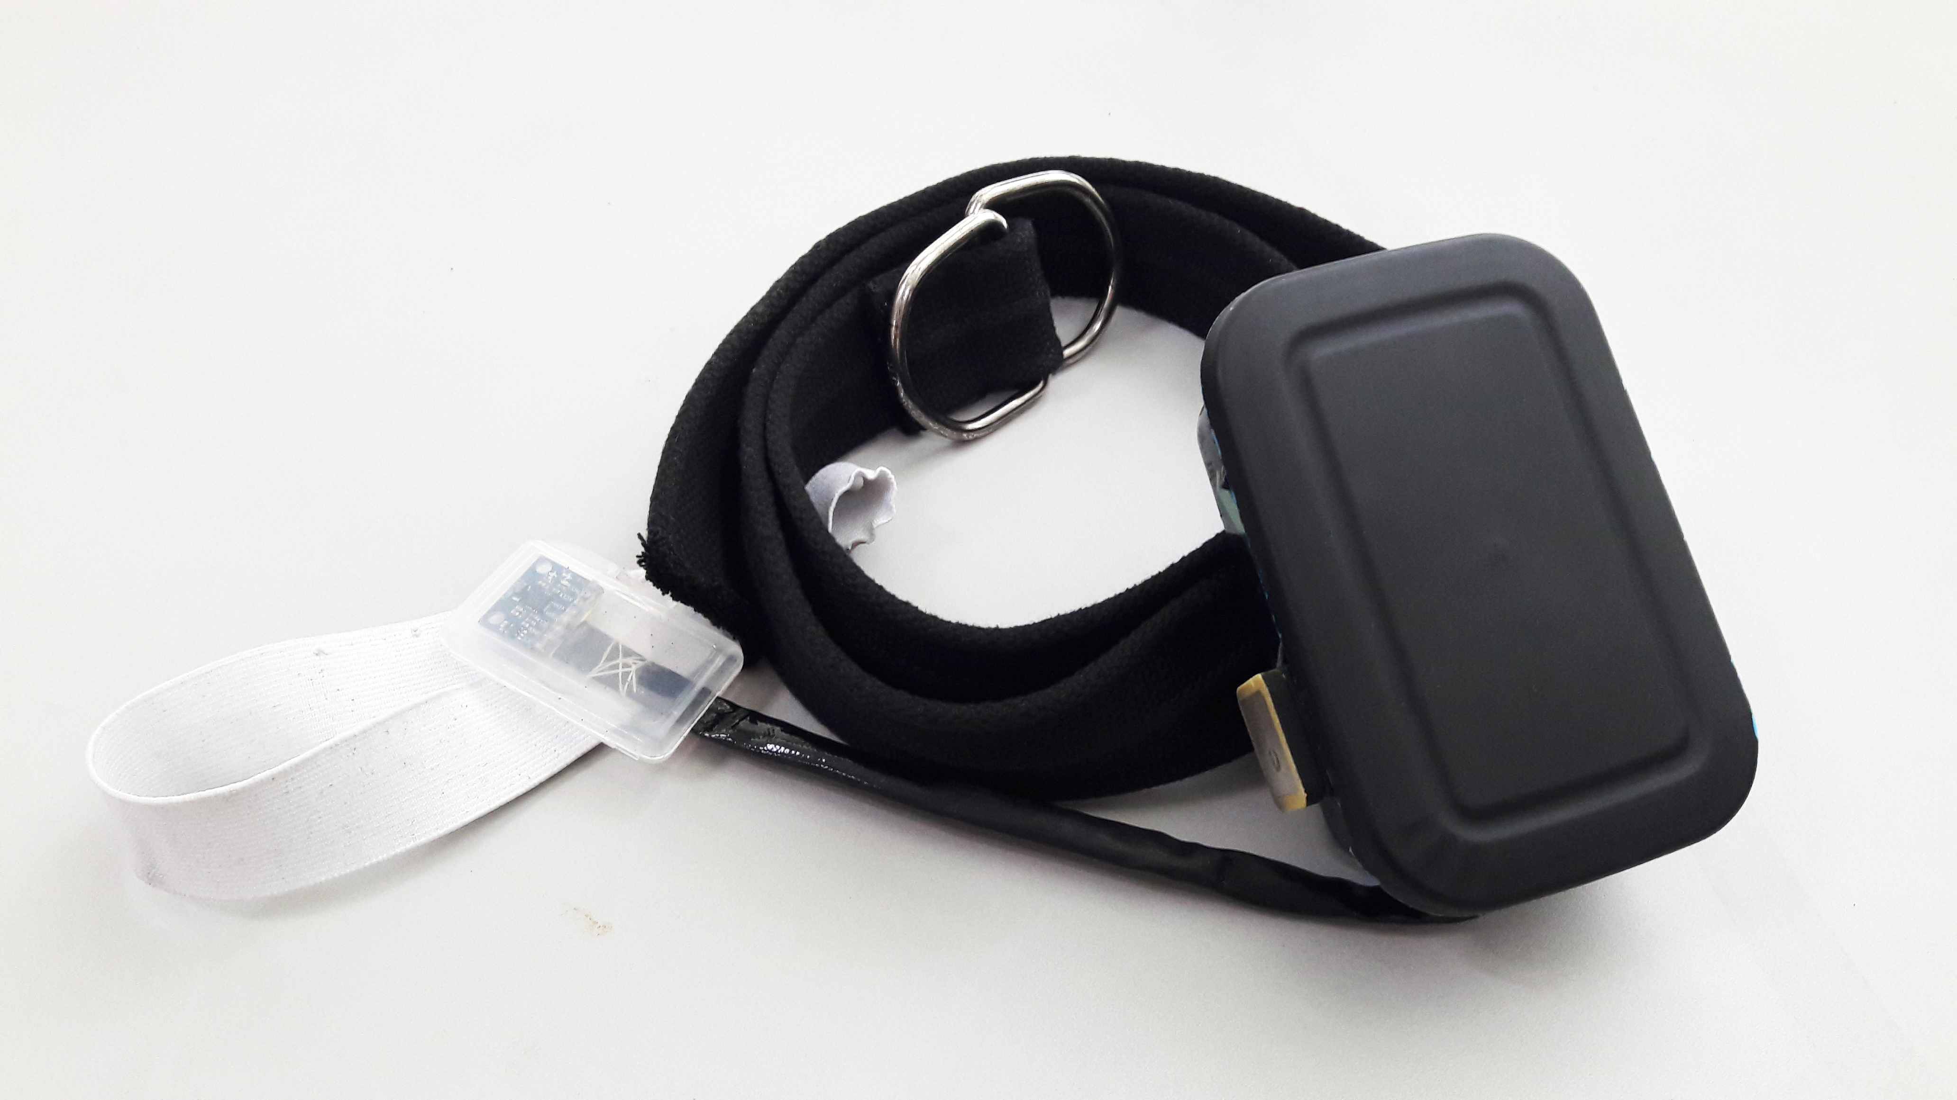

Figure 23: Fall Detection Device

* 1. Languages Used

In creating the fall analyzer device, different languages are used in the codes for a better communication and ease of use of the user of the said device. The first language used is Java. Java was used in creating the Graphical User Interface (GUI) of the device which was used for a user-friendly interaction of the user and the device. It was also used in creating the initialization page and data view page of the device. The Cascading Style Sheet (CSS) language was also used in the GUI for styling the scenes which helps for an ease of interaction of the device to the user. Lastly for creating the logic of the device, C language was used to create an algorithm to the Arduio.

CHAPTER 5

METHODOLOGY

METHODOLOGY 66

5.1 System Process 67

5.1.1 Device Initialization 69

5.1.2 Notification System 71

5.2 Implementation 72

5.2.1 Preparation, Setup and Data Acquisition 73

5.3 Evaluation 77

* 1. System Process

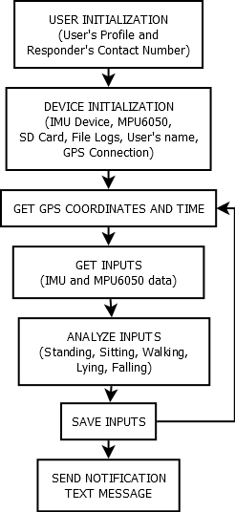

Figure 24: System Block Diagram

As seen in Figure 17, the system will have two initialization phases. First is the User Initialization where the user must insert the microSD card into a laptop and access the GUI to set its name, gender, age, address and contact number. The user must also set a username and password that will be used when modifying the activity log, deleting or adding new responders, and updating its profile. The user must input at least one (1) responder for the first initialization phase to be done. The first initialization phase is only done once, only when setting up the system. The second initialization phase will run every time the device is turned on. This is where the device turns on all the required modules connected on it. The second phase also accesses the microSD card to get the information like the username of the user, and file logs. After the initialization, the device will now continuously get the time and GPS coordinates, monitor the motion, and orientation of the user, and save it the data to the microSD card for future reference. When the device detects a sudden fall, it will send notification text message to the responders found in the microSD card if the false alarm button was not pressed after 10 seconds (Kazi, Sikander, & Yousafzai, 2014).

* + 1. Device Initialization

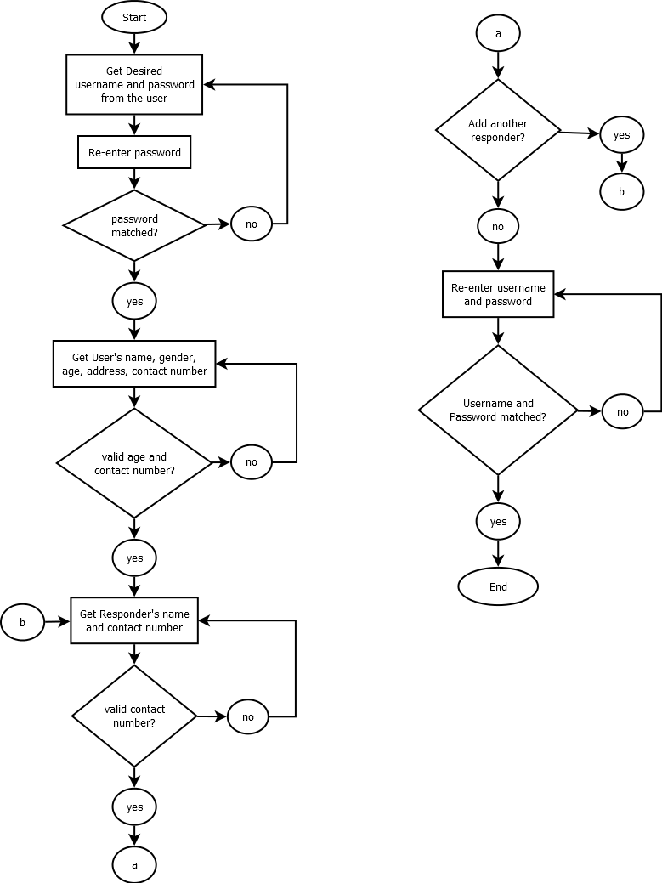

Figure 25: User Initialization

The User Initialization phase, which is run in the GUI has four (4) steps. The user must first set its username and password. The system also asks for a confirmation password before proceeding to the next step. If the confirmation password and the password did not match, the user must re-enter it again. The second step takes the user’s first and last name, gender, age, address, and contact number. The user must enter a valid age and contact number or else, it cannot proceed to the third step. The third step is where the user set its responder’s name and contact number. It must set at least one (1) responder or else, it cannot proceed to the last step. The last step for this initialization is to re-enter the username and password of the user, if matched, the initialization is done, and the user must now attach the microSD card to the device.

* + 1. Notification System

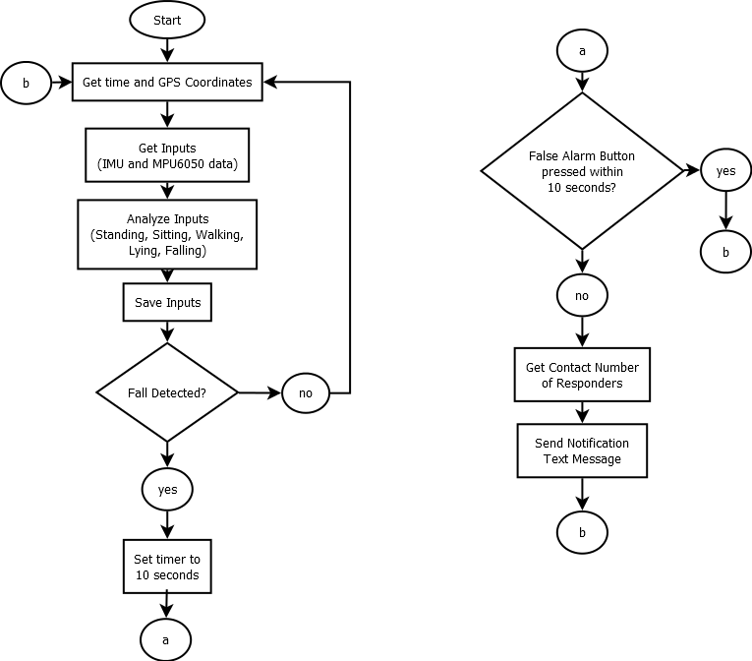

Figure 26: System Flowchart

Figure 26 shows the system flowchart in which the notification system is based. From the flowchart, the device continuously gets the time and user’s GPS coordinates, get the user’s orientation and motion, and save it to the microSD card. If the device detects a sudden fall motion, it will start a 10 seconds timer (Kazi, Sikander, & Yousafzai, 2014). If the user did not press the false alarm seconds within 10 seconds, the device will get the contact number of the responders and send them a notification text message that includes the name of the user, time when sudden fall is detected, and its GPS coordinates.

* 1. Implementation

The project follows the modified waterfall model, because each objective is important to proceed with the other objectives. The device’s process undergoes six phases and is also goal oriented. This makes each process to have an exact goal for each phase and will not be dependent on a concluding result.

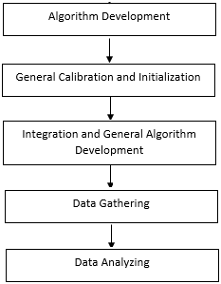

Figure 27: Waterfall Pattern

* + 1. Preparation, Setup and Data Acquisition

*Phase one – Algorithm development:*

When the result is already satisfied, the main algorithm will be created to detect the posture and movements of the user.

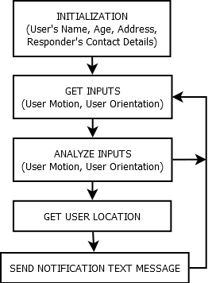

Figure 28: Block Diagram

As seen in figure 15, the device should be initialized first. In initialization, the user must connect the device first to a Bluetooth enabled computer/laptop to set the user’s name, age, and address. The user must also set the contact details of the responder/s, specifically, their names and contact numbers. After the initialization, the device will then continuously monitor the motion and orientation of the user and analyze it to determine whether the user needs an assistance. The device will consider that the user needs an assistance if it detects that the user had a sudden fall and did not respond after x minutes. If the device detects that the user had a sudden fall, the device will automatically send a text message to the set responders.

*Phase two – Integration and General Algorithm development:*

A system will be developed between different modules and sensors. The system will be shown in the development of the project on how the different components will react to each other.

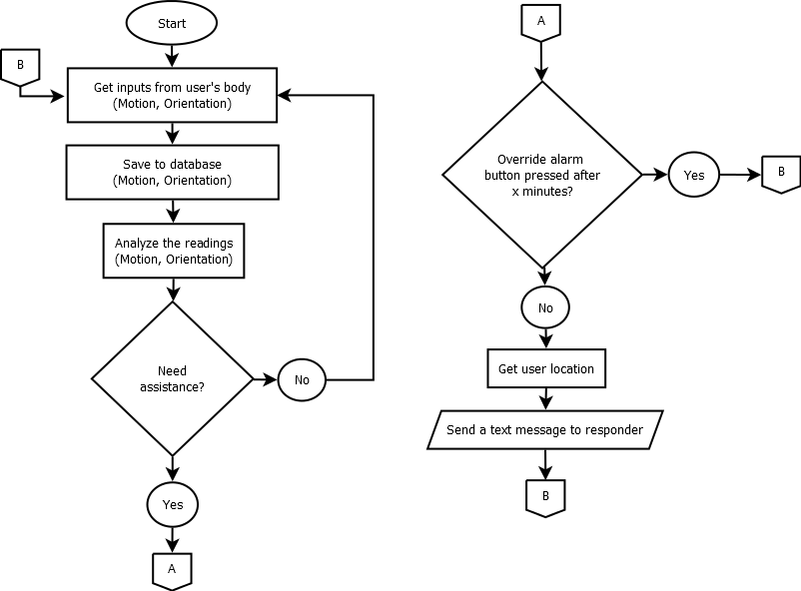

Figure 29: Flow Chart

After the initialization process, the device will continuously monitor and save the user's orientation and motion, until the device discovered a sudden fall. After the device detected that the user had a sudden fall, it will begin an x-minute countdown. If the user didn’t hit the override alarm button within x minutes, it will get the user’s GPS coordinates and will automatically send a text message to set responders stating its current GPS coordinates, and get another input from the user’s body again.

*Phase three– General Calibration and initialization:*

Accelerometers will be calibrated manually by adjusting the code of the sensors. Filters will be applied to improve the accuracy and remove unwanted noise. GPS technology of the project will be tested in different kind of places. It will be tested in an open and close area, GPS retrieve time are recorded in these tests.

SMS technology of the project is also tested, and the time will be recorded using different format of information that is ready to be sent. The project will be tweaking real-time clock (RTC) modules to put timestamps and to calculate time of a retrieved data or information. Accelerometer will be developed to analyze fall and the direction of fall such as forward, backward and sideward with 80% of accuracy upon detection. An algorithm will be created which will allow the data to gather to be save to the secure digital card (SD-card).

*Phase four – Data Gathering:*

Thirty people are needed on this phase. Following the statistical standards, 30 people will serve as the minimum number of data samples to gather. These participants are being used to identify the device’s working capability as it gathers information about the fall and motion of the subjects which can be further used in many applications in the future especially in the medical field upon innovation of the device. Each person will be given an activity such as sitting, standing walking and lying. These activities will be recorded using two accelerometers that are attached on the upper body and lower body of the subject. The accelerometers will gather the accelerations of body, time of fall and direction of the body upon falling.

* 1. Evaluation

*Phase three – Data Analyzing:*

**

Figure 30: Activity Log

The collected data can be retrieved by the responder/s. This data includes the activities done by the user before the fall happens. Activities done by the user such as walking, standing sitting and lying can be seen to better analyze the motion activity of the user before the fall. The data can also show the time of each movement so as the time, location and direction of the fall. From this data, the user’s time and location of fall was retrieved by the device and was used in sending a detailed notification system to the registered responder/s onto the device.

CHAPTER 6

RESULTS AND DISCUSSION

RESULTS AND DISCUSSION 78

6.1 Direction of Fall Output 79

6.2 Motion Detection Data 81

6.3 Confusion Matrix 82

6.4 Notification System 83

* 1. Direction of Fall Output

Falling motion is the main concern of this project. With the falling motion, detection of fall and its direction are to be considered to call the device a fall analyzer. From the experiment’s data, gathered over 30 respondents, participants are asked to do a falling motion with three classifications of fall based on the direction namely: forward fall, side fall and backward fall. Results are shown from the table 6.1

Table 6.1 Falling Motions Data

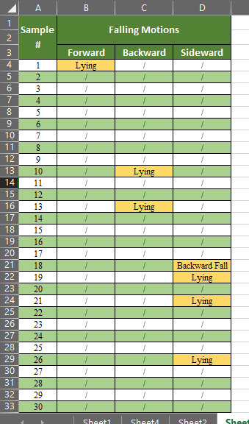

From Table 6.1, the device shows that it can detect fall and the direction of fall. Within 30 participants, the device shows that it can detect forward fall with 96.66% accuracy that resulted from a 29 out of 30 accurate forward fall results. On the other hand, backward fall resulted in 93.33% of backward fall accuracy detection and 86.67% for side fall accuracy detection. Overall fall detection gives a reliability of 92.22% accuracy in detection such motion.

The data shows that the device can clearly recognize forward fall with only 3.33% error. This is because the device recognizes only such direction and motion that does not have any other alike motion that insist a moving forward action. The backward fall follows with 6.67% rate of error. The device sometimes recognizes backward fall as just a lying motion if the user fell in a slow acceleration. As lying position induces a backward motion, the acceleration of the user will be the only boundary that separates the two motions in which if the device recognizes motions that are exactly in between the two, the 6.67% error of backward fall motion comes to reason. Lastly, sideward fall came with 13.33% error which is the highest error among the three falling motions. This is because of the device’s sensitivity in recognizing the fall. As the user fell sideward, the device should recognize a sideward fall motion however, as user hits the ground, the algorithm computes the last position of the user as they fell basing from the initial position before they fell. In such case, if the user falls sideways, but hits the ground backside, the device recognizes a backward fall motion because of the last position of the user is will be in a slight facing up position. This makes the side fall detection the most sensitive of the three directions due to the position to consider after the user has fallen.

* 1. Motion Detection Data

Detection of other motions other than the falling motion is a sub-feature of this device. These motions to be detected are divided into two categories such as static motions and dynamic motions. Static motions such as sitting, standing and lying can be detected by this device so as the walking motion under the dynamic category. Table 6.2 shows the result of the device capability on recognizing such motions with experimenting the device’s ability to identify the mentioned specific motions with 30 participants as a subject.

Table 6.2 Motion Detection Data

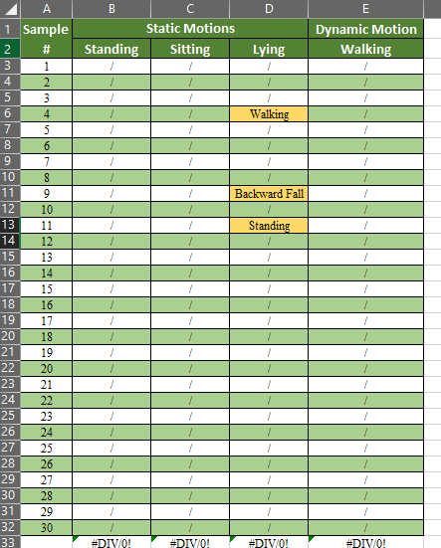

From table 6.2, specific motions data such as standing, sitting, lying and walking can be seen. A 100% reliability rate was able to achieve by the device in recognizing motions such as standing, sitting and walking. Because these motions do not interfere with any other motions that this device can detect, the complete success rate on motion recognition was achieved, however in detecting the lying motion, only 90% accuracy rate was reached. This is because the device sometimes recognizes lying motion into a falling motion or in other cases it stops on the detection of the previous motion before the lying motion, just like the result on the table above shows.

* 1. Confusion Matrix

Over all, falling and motion detection data can be seen in table 6.3. The table below shows the confusion matrix of all motions including the direction of the falling motion. From the table, it shows that the overall reliability of the device in detecting motions such as walking, standing, sitting, lying, forward fall, backward fall and side fall is 95.23% which makes the error of the device be only at 4.76% only.

Table 6.3 Confusion Matrix

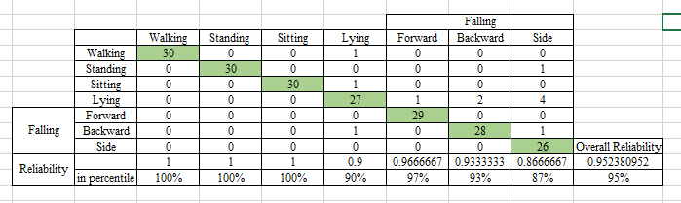

* 1. Notification System

As the user fell, a notification system was activated. Using GSM technology, an SMS was sent into the recorded responder/s. In the message, the name of the user, location where the fall happened, date of fall and time of fall was included into the notification message.

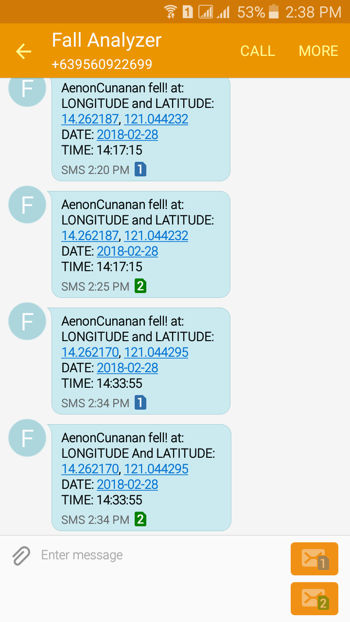

Figure 31: Notification Message

Figure 31 shows the notification messages to two different responders. Responder 1 uses sim1 and responder 2 uses sim 2. As can be seen from the image above, the device has sent the user’s name and details such as location, date and time after he fell. Notice that the device sent the message to the two responders with after the fall with approximately 1 minute after the fall. The location of fall was presented into coordinates and on Figure 32, the sent coordinates can be found on the google maps to be located at De La Salle University – Manila Laguna Campus. However, when the user has fallen and decided to hit the false alarm button before 10 seconds, the message notification system was override and message was not sent.

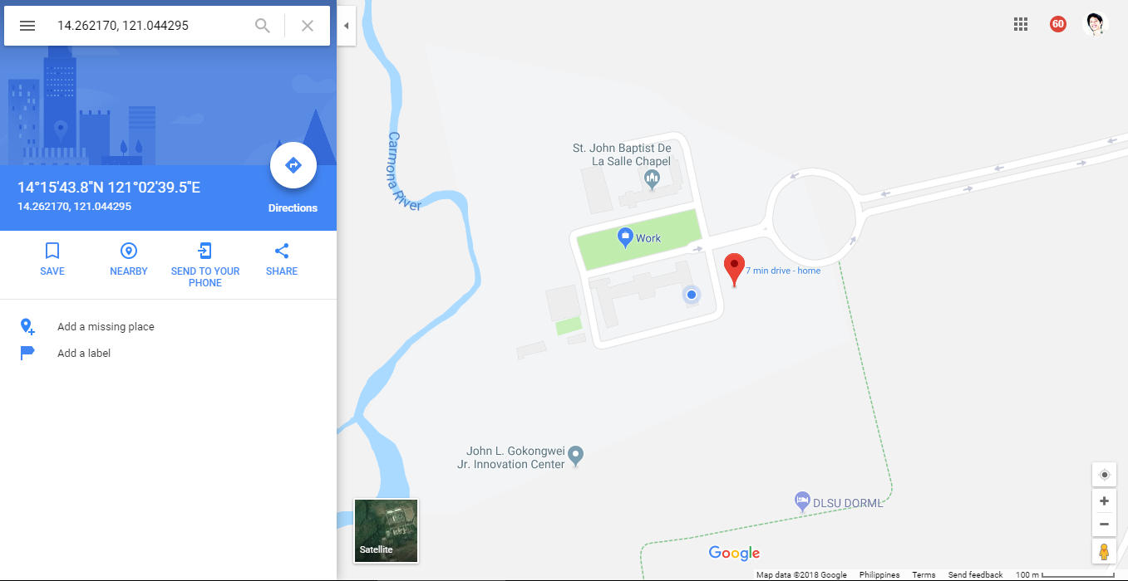

Figure 32: Location of Fall from Google Maps

CHAPTER 7

CONCLUSIONS, RECOMMENDATIONS, AND FUTURE DIRECTIVES

CONCLUSIONS, RECOMMENDATIONS, AND FUTURE DIRECTIVES 85

7.1 Concluding Remarks 86

7.2 Contributions 88

7.3 Recommendations 89

7.4 Future Prospects 90

* 1. Concluding Remarks

Designing a device that can detect motion of user such as standing, sitting, lying, walking and falling with direction detection of fall whether the fall is in forward, sideward or backward motion was successfully developed with 95% of the device’s accuracy of detection. When falling motion was established, the notification system of the device was activated, and message was sent to the recorded responder/s with details such as location of fall, time of fall, name of user who has fallen and the date of fall.

The use of two accelerometers located at the waist and hip resulted as a good component in making a motion detection device with 92.22% reliability. The development of falling device that can recognize direction of fall with the use of the same two modules resulted with 92.22% of accuracy which supports the conclusion of the detection of the user’s orientation of fall whether the user has fallen backward, forward or sideward to be achieved. The GPS module gave the duration of fall that includes time and date of the user’s fall.

Data based was also created and location, time, date and motions that are detected from the start the device was activated until the fall happen was saved into the SD card and data saved was retrieved into the GUI which data came from the data log that was saved on the SD card. The GUI interface can interact with the user of the device as it was created with friendly-user functions and directions.

Motion detection such as standing, sitting, walking and lying that are sub-feature of this device was successfully detected with 97.5% overall accuracy rate. As a general conclusion, the design and development of fall analyzer with specific motion detection which can be personalized with the function of send notification message to recorded responder/s during the fall was achieved with above 80% acceptable accuracy rate.

* 1. Contributions

The synthesis of all the contributions that this thesis has made and developed are as follows:

* Fall detection with the recognition of fall direction whether backward, sideways or forward.
* Detection of motions such as standing, sitting, lying and walking with data logging of such motions which can be access by the responder/s thru GUI.
* Notification and alarm system via GSM with GPS location, and time data included on the responder’s notification message.
  1. Recommendations

For future innovation of the study, detection of motions along a not plain terrain like stairs and alike is recommended. Power management of the device must also be improved for the further improvement of this study as this project limits itself on the detection. The location of the user when fallen in this project can be identified using the GPS coordinates, so for further study, the use of exact address in locating the user is suggested. Lastly, a training process of the device’s system can be added for better acknowledgement of motions for every different user.

* 1. Future Prospects

In further accretion of this device, the use of fall and motion detection can be used in medical field. This can serve as a monitoring device to patients like old people who might have suffer fall related injuries. Using this technology, accidents related to fall can be prevented and can be taken care of as quickly as possible. Using the real-time notification system with the included time, location and might include the previous activity of patient before fall, a monitoring device such this can be helpful.

Another application for future use of this device is for manpower activity detection. Due to the location register and activity log of the device, this can detect the activity of the user for example in shopping mall, the device can be used by the sales person and the manager can detect whether his/her employee is working or in his/her assigned work location.

References

Cambridge University Press. (2017). Fall. Cambridge, England.

Crisostomo, S. (2014, July 06). Fall Accidents 5th leading cause of Phl kids' deaths. *The Philippine Star*.

Fotune, E., Lugade, V. A., & Kaufman, K. R. (2014). Posture and Movement Classification: The Comparison of Tri-Axial Accelerometer Numbers and Anatomicl Placement. *Journal of Biomechanical Engineering* (pp. 1-8). ASME.

Guevarra, D. G., & Evangelista, T. P. (2010). The Incidence and Identification of Risk Factors for Falls among Filipini Elederly Person in a Nursing Home Facility and at the Rehabilitation Medicine Out-Patient Department of the Philippine General Hospital. *ACTA MEDICA PHILIPPINA, 44*(2).

Gurkan, K., Gurkan, G., Dindar, A., Akpinar, B., & Gulal, Engin. (2014). Wireless 3-Axis Acelerometer System for Measuring of Structural Displacement. *Engineering Structures* (pp. 403-406). Istabul: IEEE.

Gurkan, K., Gurkan, G., Dindar, A., Akpmar, B., & Gulal, E. (n.d.). Wireless 3-Axis Accelerometer System for Measurement of Structural Displacement.

Hermanis, A., Nesenbergs, K., Cacrus, R., & Greitans, M. (2013). Wearable Posture Monitoring System with Biofeedback via Smartphone. *Journal of Medical and Bioengineering* (pp. 40-44). Latvia: IEEE.

Huynh, Q. T., Nguyen, U. D., Tran, S. V., Nabili, A., & Tran, B. Q. (2013). Fall Detection System Using Combination accelerometer and Gyroscope. *Proc. of the Second Intl. Conf. on Advances in ElectronicnDevices.* Hochiminh\.

Igual, R., Medrano, C., & Plaza, I. (2013). *Challenges, issues and trens in fall detection systems.* Retrieved from Biomedical Engineering OnLine: http://www.biomedical-engineering-online.com/content/12/1/66

Jovanov, E., Milenkovic, A., Otto, C., & De Groen, P. C. (2005). A Wireless Body Area Network of Intelligent Motion Sensors for Computer Assisted Physical Rehabilitation. *Journal of Neuro Engineering and Rehabilitation 20052:6.*

Kazi, S. B., Sikander, S., & Yousafzai, S. (2014). Fall Detection Using Single Tri-Axial Accelerometer. *ASEE 2014 Zone I.* Bridgeport.

Li, Q., Hanson, M. A., Stankovic, J. A., Barth, A. T., & Lach, J. (2009). Accurate, Fast Fall Detection Using Gyroscopes and Accelerometer-Derived Posture Information. *Body Sensor Networks.* Virginia.

Li, Q., Stankovic, J. A., Hanson, M., Barth, A., & Lach, J. (2009). Accurate, Fast Fall Detection Using Gyroscope and Accelerometer-Derived Posture Information. Virginia: Gang Zhou.

Marinas, J. S., Maddunba, J. A., Consunji, R. J., & Dela Paz Jr., D. A. (2011, July 3). A Profile of deaths among trauma patients in a university hospital: The Philippine experience. *Injury and Violence*, pp. 85-89.

Park, S., & Jayaraman, S. (2003). Enhancing the Quality of Life Through Wearable Technology. *Engineering in Medicene and Biology Magazine* (pp. 41-48). IEEE.

Safran Colibrys SA. (2018). *MEMS Accelerometers*. Retrieved from SAFRAN: https://ww.colibrys.com/c/technology/mems-accelerometers/

Sudarshan, B. G., Raveendra, H., Prasanna, K. C., & Satyanarayana, B. S. (2013). Design and Developmet of Fall Detector Using Fall Acceleration. *IJRET: International Journal of Research in Engineering Technology*, (pp. 57-61). Karmataka, India.

Wu, F., Zhao, Y., Zhao, H., & Zhong, H. (2014). Development of a Wearable-Sensor-Based Fall Detection System. *International Journal of Telemedecine and Applications, 2015*(1), 11.